An Efficient Privacy-enhancing Cross-silo Federated Learning and Applications for False Data Injection Attack Detection in Smart Grids
1.INTRODUCTION:
Federated learning is an emerging machine learning paradigm which addresses critical data privacy issues by enabling clients to store their raw data locally and transfer only their updated local model parameters to an aggregator server for jointly training a global model. Due to this characteristic, federated learning offers significant privacy improvements over centralizing all the training data. However, federated learning is vulnerable to inference attacks from dishonest aggregators who can infer information about clients’ training data from their model parameters (weights, gradients). For example, employed generative adversarial networks to infer the private data of a target client from its shared model parameters. This means that even if the model is trained in federated learning, data privacy still cannot be rigorously guaranteed. Information can be extracted from global model parameters, but this information cannot be linked to a specific single client because the data samples are anonymized among multiple clients. However, this is not the case if the information is inferred from local model parameters by a corrupted aggre- Thus, clients’ model parameters should be protected from the access of a corrupted aggregator to prohibit these potential inference attacks. To address this problem, existing approaches focus on two main techniques, which are differential privacy-based and secure aggregation-based. The former adds noise directly to the client’s models over a numerous number of iterations; thus, it has the drawbacks of sacrificing the global model accuracy to make a trade-off of privacy-utility. The latter utilizes techniques in cryptography such as secure multiparty computation and homomorphic encryption to securely aggregate the clients’ models without knowing their specific values. However, most of these existing approaches rely on a trusted third party to generate the master key for aggregation or a setting with multiple non colluding servers. Besides, many proposed schemes are still inefficient and impractical due to the expensive overhead of computation and communication among multiple clients over multiple rounds of training. False data injection attack (FDIA) detection is a critical security operation in a smart grid control system. and has been solved by data-driven machine learning methods. The data-driven machine learning methods require a huge amount of measurement data which are distributed over an interconnected grid. In such an interconnected grid, each sub-grid is possessed and managed by an independent transmission grid company (TGC) regarding power industry deregulation. To build a high-accuracy model for false data injection detection, measurement data from all involved sub-grids should be shared. However, transmitting such huge measurement data over the network for a cenIEEE Transactions on Information Forensics and Security with Machine Learning, Volume:18,Issue Date:17.April.2023 2 tralized detection machine learning algorithm is expensive and also leads to security and privacy issues including competitive privacy. The question is how to coordinate these TGCs to detect FDI attacks while preserving their competitive privacy. This remains a challenging problem which has been attracting recent studies with federated learning-based solutions. In federated learning, a cross-silo setting is often established where a number of companies or organizations have a common incentive to train a model based on all of their data, but do not share their data directly due to confidentiality/privacy or legal constraints. To enhance the privacy of power companies when they contribute their local training models, an efficient privacypreserving cross-silo federated learning for FDIA detection over multi-area transmission grids should be designed. In view of the above issues, we propose an efficient cross-silo federated learning with strong privacy preservation which can be applicable to the smart grid domain. By designing a double-layer encryption scheme over multiple federated learning rounds and utilizing Shamir secret sharing, we achieve an efficient privacy-preserving federated learning protocol, which also allows some clients to drop out and rejoin dynamically during the training process. Specifically, we summarize the main contributions as follows: A general privacy-enhancing cross-silo federated learning with a secure weighted aggregation scheme is designed based on lightweight double-layer encryption and Shamir secret sharing. The scheme removes the requirement of computing discrete logarithms which is the limitation of some related works. No multiple non-colluding server settings are required. Besides, clients’ secret keys of two encryption layers are generated in a decentralized manner which helps increase privacy. The proposed scheme is demonstrated theoretically and empirically to provide provable privacy against an honest-but-curious aggregator server and simultaneously achieve desirable model utility. The proposed scheme is efficient in communication/computation and robust against dropouts/rejoining during training iterations. An efficient privacy-enhancing cross-silo federated learning resilient to the local training data inference attacks for FDIA detection in the smart grid domain is proposed and empirically evaluated. This paper consists of eight sections. Following this Introduction section are the Related Works and Preliminaries sections. The proposed privacy-enhancing cross-silo federated learning without any trusted third parties is given in Section 4, followed by the analysis of the scheme in Section 5. A concrete scenario of enhancing privacy in cross-silo federated learning for FDIA detection in smart grids with empirical evaluation is given in Section 6 and Section 7. Finally, Section 8 is for the discussion and conclusions.
  - Objective of the project:
Federated Learning is a prominent machine learning paradigm which helps tackle data privacy issues by allowing clients to store their raw data locally and transfer only their local model parameters to an aggregator server to collaboratively train a shared global model. However, federated learning is vulnerable to inference attacks from dishonest aggregators who can infer information about clients’ training data from their model parameters. To deal with this issue, most of the proposed schemes in literature either require a non-colluded server setting, a trusted third-party to compute master secret keys or a secure multiparty computation protocol which is still inefficient over multiple iterations of computing an aggregation model. In this work, we propose an efficient cross-silo federated learning scheme with strong privacy preservation. By designing a double-layer encryption scheme which has no requirement to compute discrete logarithm, utilizing secret sharing only at the establishment phase and in the iterations when parties rejoin, and accelerating the computation performance via parallel computing, we achieve an efficient privacy-preserving federated learning protocol, which also allows clients to dropout and rejoin during the training process. The proposed scheme is demonstrated theoretically and empirically to provide provable privacy against an honest-but-curious aggregator server and simultaneously achieve desirable model utilities. The scheme is applied to false data injection attack detection (FDIA) in smart grids. This is a more secure cross-silo FDIA federated learning resilient to the local private data inference attacks than the existing works.
2. LITERATURESURVEY:

Exploration of Communication Networks from the Enron Email Corpus
The Enron email corpus is appealing to researchers because it is a) a large scale email collection from b) a real organization c) over a period of 3.5 years. In this paper we contribute to the initial investigation of the Enron email dataset from a social network analytic perspective. We report on how we enhanced and refined the Enron corpus with respect to relational data and how we extracted communication networks from it. We apply various network analytic techniques in order to explore structural properties of the networks in Enron and to identify key players across time. Our initial results indicate that during the Enron crisis the network had been denser, more centralized and more connected than during normal times. Our data also suggests that during the crisis the communication among Enron’s employees had been more diverse with respect to people’s formal positions, and that top executives had formed a tight clique with mutual support and highly brokered interactions with the rest of organization. The insights gained with the analyses we perform and propose are of potential further benefit for modeling the development of crisis scenarios in organizations and the investigation of indicators of failure.

A validation of object-oriented design metrics as quality indicators
This paper presents the results of a study in which we empirically investigated the suite of object-oriented (OO) design metrics introduced in (Chidamber and Kemerer, 1994). More specifically, our goal is to assess these metrics as predictors of fault-prone classes and, therefore, determine whether they can be used as early quality indicators. This study is complementary to the work described in (Li and Henry, 1993) where the same suite of metrics had been used to assess frequencies of maintenance changes to classes. To perform our validation accurately, we collected data on the development of eight medium-sized information management systems based on identical requirements. All eight projects were developed using a sequential life cycle model, a well-known OO analysis/design method and the C++ programming language. Based on empirical and quantitative analysis, the advantages and drawbacks of these OO metrics are discussed. Several of Chidamber and Kemerer's OO metrics appear to be useful to predict class fault-proneness during the early phases of the life-cycle. Also, on our data set, they are better predictors than "traditional" code metrics, which can only be collected at a later phase of the software development processes.

RICH: Automatically Protecting Against Integer-Based Vulnerabilities
We present the design and implementation of RICH (Run-time Integer CHecking), a tool for efﬁciently detecting integer-based attacks against C programs at run time. C integer bugs, a popular avenue of attack and frequent programming error [1–15], occur when a variable value goes out of the range of the machine word used to materialize it, e.g. when assigning a large 32-bit int to a 16-bit short. We show that safe and unsafe integer operations in C can be captured by well-known sub-typing theory. The RICH compiler extension compiles C programs to object code that monitors its own execution to detect integer-based attacks. We implemented RICH as an extension to the GCC compiler and tested it on several network servers and UNIX utilities. Despite the ubiquity of integer operations, the performance overhead of RICH is very low, averaging about 5%. RICH found two new integer bugs and caught all but one of the previously known bugs we tested. These results show that RICH is a useful and lightweight software testing tool and run-time defense mechanism. RICH may generate false positives when programmers use integer overﬂows deliberately, and it can miss some integer bugs because it does not model certain C features.

CSSV: Towards a realistic tool for statically detecting all buffer overflows in C

Erroneous string manipulations are a major source of software defects in C programs yielding vulnerabilities which are exploited by software viruses. We present C String Static Verifyer (CSSV), a tool that statically uncovers all string manipulation errors. Being a conservative tool, it reports all such errors at the expense of sometimes generating false alarms. Fortunately, only a small number of false alarms are reported, thereby proving that statically reducing software vulnerability is achievable. CSSV handles large programs by analyzing each procedure separately. To this end procedure contracts are allowed which are verified by the tool.We implemented a CSSV prototype and used it to verify the absence of errors in real code from EADS Airbus. When applied to another commonly used string intensive application, CSSV uncovered real bugs with very few false alarms. Improving security using extensible lightweight static analysis
Most security attacks exploit instances of well-known classes of implementation flaws. Developers could detect and eliminate many of these flaws before deploying the software, yet these problems persist with disturbing frequency-not because the security community doesn't sufficiently understand them but because techniques for preventing them have not been integrated into the software development process. This article describes an extensible tool that uses lightweight static analysis to detect common security vulnerabilities (including buffer overflows and format string vulnerabilities).

Automated Whitebox Fuzz Testing
Fuzz testing is an effective technique for finding security vulnerabilities in software. Traditionally, fuzz testing tools apply random mutations to well-formed inputs of a pro- gram and test the resulting values. We present an alterna- tive whitebox fuzz testing approach inspired by recent ad- vances in symbolic execution and dynamic test generation. Our approach records an actual run of the program un- der test on a well-formed input, symbolically evaluates the recorded trace, and gathers constraints on inputs capturing how the program uses these. The collected constraints are then negated one by one and solved with a constraint solver, producing new inputs that exercise different control paths in the program. This process is repeated with the help of a code-coverage maximizing heuristic designed tofind defects as fast as possible. We have implemented this algorithm in SAGE (Scalable, Automated, Guided Execution), a new tool employing x86 instruction-level tracing and emulation for whitebox fuzzing of arbitrary file-reading Windows ap- plications. We describe key optimizations needed to make dynamic test generation scale to large input files and long execution traces with hundreds of millions of instructions. We then present detailed experiments with several Windows applications. Notably, without any format-specific knowl- edge, SAGE detects the MS07-017 ANI vulnerability, which was missed by extensive blackbox fuzzing and static analy- sis tools. Furthermore, while still in an early stage of de- velopment, SAGE has already discovered 30+ new bugs in large shipped Windows applications including image pro- cessors, media players, and file decoders. Several of these bugs are potentially exploitable memory access violations.
Existing System
In Existing system, we are using ,machine learning algorithms like k-means, random forest and decision tree to develop vulnerability detection tool
Disadvantages
1.Less accuracy.
PROPOSED SYSTEM
In proposed system, we are using Ensemble Machine Learning algorithm which is combination of multiple algorithms such as SVM, KNN and Naïve Bayes.
Now-a-days Machine Learning algorithms are using everywhere from Medical disease prediction to road side traffic prediction as this algorithms prediction accuracy is more than 95%.
Above success of Machine Learning algorithms are migrating us to develop vulnerability detection tool using machine learning algorithms. Machine Learning algorithms get trained on past data and then can analyse new test data to predict it class of Normal or Vulnerability type.
In propose work we are using dataset to identify 3 different classes such as ‘No Vulnerability, SQL Injection, XSS or RFI.
Advantages
- High Accuracy
Modules:
To implement this project we have designed following Modules
- New User Register: new user can register with the application
- User Login: after sign up user can login to application
- Load Dataset: after login user can upload dataset to application and then extract all queries and labels from dataset and then from all queries will remove stop words like ‘and, the, or, what and many other words’. By removing stop words application will have core queries words. Dataset processing for core words will be happened using Natural Language processing toolkit
- Run Ensemble Algorithms: processed dataset will be input to Ensemble Machine learning algorithm to train a model and this model will be applied on test data to calculate accuracy and other metrics
- Confusion Matrix Graph: using this module we will plot confusion matrix graph of algorithm prediction capability
- Predict Vulnerability: using this module will upload new TEST data query and then Machine learning algorithm will analyse all TEST data and predict type of vulnerability.
3.3. PROCESS MODEL USED WITH JUSTIFICATION
SDLC (Umbrella Model):
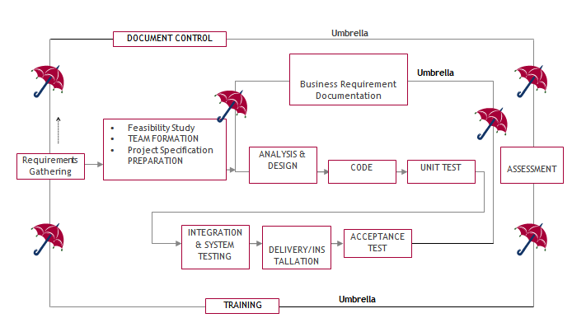
The requirements gathering process takes as its input SDLC is nothing but Software Development Life Cycle. It is a standard which is used by software industry to develop good software.
Stages in SDLC:
- Requirement Gathering
- Analysis
- Designing
- Coding
- Testing
- Maintenance
Requirements Gathering stage:
the goals identified in the high-level requirements section of the project plan. Each goal will be refined into a set of one or more requirements. These requirements define the major functions of the intended application, define operational data areas and reference data areas, and define the initial data entities. Major functions include critical processes to be managed, as well as mission critical inputs, outputs and reports. A user class hierarchy is developed and associated with these major functions, data areas, and data entities. Each of these definitions is termed a Requirement. Requirements are identified by unique requirement identifiers and, at minimum, contain a requirement title and textual description.
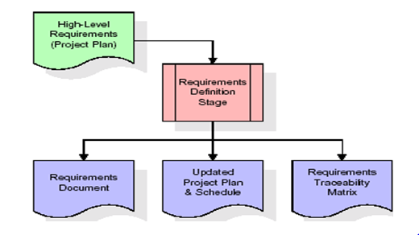

These requirements are fully described in the primary deliverables for this stage: the Requirements Document and the Requirements Traceability Matrix (RTM). The requirements document contains complete descriptions of each requirement, including diagrams and references to external documents as necessary. Note that detailed listings of database tables and fields are not included in the requirements document.
The title of each requirement is also placed into the first version of the RTM, along with the title of each goal from the project plan. The purpose of the RTM is to show that the product components developed during each stage of the software development lifecycle are formally connected to the components developed in prior stages.
In the requirements stage, the RTM consists of a list of high-level requirements, or goals, by title, with a listing of associated requirements for each goal, listed by requirement title. In this hierarchical listing, the RTM shows that each requirement developed during this stage is formally linked to a specific product goal. In this format, each requirement can be traced to a specific product goal, hence the term requirements traceability.
The outputs of the requirements definition stage include the requirements document, the RTM, and an updated project plan.
- Feasibility study is all about identification of problems in a project.
- No. of staff required to handle a project is represented as Team Formation, in this case only modules are individual tasks will be assigned to employees who are working for that project.
- Project Specifications are all about representing of various possible inputs submitting to the server and corresponding outputs along with reports maintained by administrator.
Analysis Stage:
The planning stage establishes a bird's eye view of the intended software product, and uses this to establish the basic project structure, evaluate feasibility and risks associated with the project, and describe appropriate management and technical approaches.
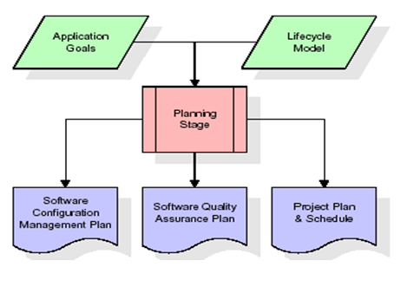

The most critical section of the project plan is a listing of high-level product requirements, also referred to as goals. All of the software product requirements to be developed during the requirements definition stage flow from one or more of these goals. The minimum information for each goal consists of a title and textual description, although additional information and references to external documents may be included. The outputs of the project planning stage are the configuration management plan, the quality assurance plan, and the project plan and schedule, with a detailed listing of scheduled activities for the upcoming Requirements stage, and high level estimates of effort for the out stages.
Designing Stage:
The design stage takes as its initial input the requirements identified in the approved requirements document. For each requirement, a set of one or more design elements will be produced as a result of interviews, workshops, and/or prototype efforts. Design elements describe the desired software features in detail, and generally include functional hierarchy diagrams, screen layout diagrams, tables of business rules, business process diagrams, pseudo code, and a complete entity-relationship diagram with a full data dictionary. These design elements are intended to describe the software in sufficient detail that skilled programmers may develop the software with minimal additional input.
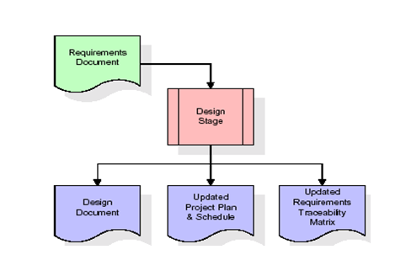
When the design document is finalized and accepted, the RTM is updated to show that each design element is formally associated with a specific requirement. The outputs of the design stage are the design document, an updated RTM, and an updated project plan.
Development (Coding) Stage:
The development stage takes as its primary input the design elements described in the approved design document. For each design element, a set of one or more software artifacts will be produced. Software artifacts include but are not limited to menus, dialogs, and data management forms, data reporting formats, and specialized procedures and functions. Appropriate test cases will be developed for each set of functionally related software artifacts, and an online help system will be developed to guide users in their interactions with the software.
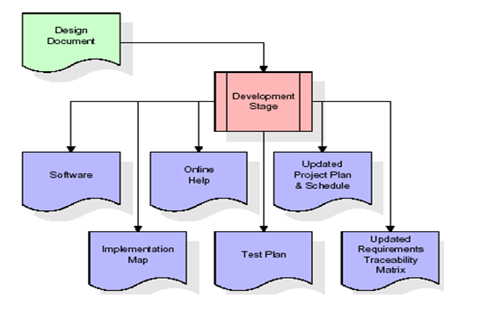
The RTM will be updated to show that each developed artifact is linked to a specific design element, and that each developed artifact has one or more corresponding test case items. At this point, the RTM is in its final configuration. The outputs of the development stage include a fully functional set of software that satisfies the requirements and design elements previously documented, an online help system that describes the operation of the software, an implementation map that identifies the primary code entry points for all major system functions, a test plan that describes the test cases to be used to validate the correctness and completeness of the software, an updated RTM, and an updated project plan.
Integration & Test Stage:
During the integration and test stage, the software artifacts, online help, and test data are migrated from the development environment to a separate test environment. At this point, all test cases are run to verify the correctness and completeness of the software. Successful execution of the test suite confirms a robust and complete migration capability. During this stage, reference data is finalized for production use and production users are identified and linked to their appropriate roles. The final reference data (or links to reference data source files) and production user list are compiled into the Production Initiation Plan.

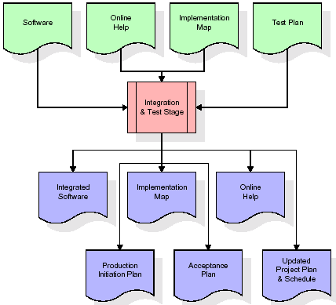
The outputs of the integration and test stage include an integrated set of software, an online help system, an implementation map, a production initiation plan that describes reference data and production users, an acceptance plan which contains the final suite of test cases, and an updated project plan.
- Installation & Acceptance Test:
During the installation and acceptance stage, the software artifacts, online help, and initial production data are loaded onto the production server. At this point, all test cases are run to verify the correctness and completeness of the software. Successful execution of the test suite is a prerequisite to acceptance of the software by the customer.
After customer personnel have verified that the initial production data load is correct and the test suite has been executed with satisfactory results, the customer formally accepts the delivery of the software.

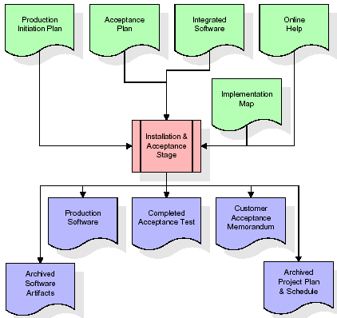

The primary outputs of the installation and acceptance stage include a production application, a completed acceptance test suite, and a memorandum of customer acceptance of the software. Finally, the PDR enters the last of the actual labor data into the project schedule and locks the project as a permanent project record. At this point the PDR "locks" the project by archiving all software items, the implementation map, the source code, and the documentation for future reference.
Maintenance:
Outer rectangle represents maintenance of a project, Maintenance team will start with requirement study, understanding of documentation later employees will be assigned work and they will undergo training on that particular assigned category. For this life cycle there is no end, it will be continued so on like an umbrella (no ending point to umbrella sticks).
3.4. Software Requirement Specification
3.4.1. Overall Description
A Software Requirements Specification (SRS) – a requirements specification for a software system is a complete description of the behavior of a system to be developed. It includes a set of use cases that describe all the interactions the users will have with the software. In addition to use cases, the SRS also contains non-functional requirements. Nonfunctional requirements are requirements which impose constraints on the design or implementation (such as performance engineering requirements, quality standards, or design constraints).
System requirements specification: A structured collection of information that embodies the requirements of a system. A business analyst, sometimes titled system analyst, is responsible for analyzing the business needs of their clients and stakeholders to help identify business problems and propose solutions. Within the systems development lifecycle domain, the BA typically performs a liaison function between the business side of an enterprise and the information technology department or external service providers. Projects are subject to three sorts of requirements:
- Business requirements describe in business terms what must be delivered or accomplished to provide value.
- Product requirements describe properties of a system or product (which could be one of several ways to accomplish a set of business requirements.)
- Process requirements describe activities performed by the developing organization. For instance, process requirements could specify .Preliminary investigation examine project feasibility, the likelihood the system will be useful to the organization. The main objective of the feasibility study is to test the Technical, Operational and Economical feasibility for adding new modules and debugging old running system. All system is feasible if they are unlimited resources and infinite time. There are aspects in the feasibility study portion of the preliminary investigation:

- ECONOMIC FEASIBILITY
A system can be developed technically and that will be used if installed must still be a good investment for the organization. In the economical feasibility, the development cost in creating the system is evaluated against the ultimate benefit derived from the new systems. Financial benefits must equal or exceed the costs. The system is economically feasible. It does not require any addition hardware or software. Since the interface for this system is developed using the existing resources and technologies available at NIC, There is nominal expenditure and economical feasibility for certain.
- Operational Feasibility
Proposed projects are beneficial only if they can be turned out into information system. That will meet the organization’s operating requirements. Operational feasibility aspects of the project are to be taken as an important part of the project implementation. This system is targeted to be in accordance with the above-mentioned issues. Beforehand, the management issues and user requirements have been taken into consideration. So there is no question of resistance from the users that can undermine the possible application benefits. The well-planned design would
Ensure the optimal utilization of the computer resources and would help in the improvement of performance status.
- TECHNICAL FEASIBILITY
Earlier no system existed to cater to the needs of ‘Secure Infrastructure Implementation System’. The current system developed is technically feasible. It is a web based user interface for audit workflow at NIC-CSD. Thus it provides an easy access to .the users. The database’s purpose is to create, establish and maintain a workflow among various entities in order to facilitate all concerned users in their various capacities or roles. Permission to the users would be granted based on the roles specified. Therefore, it provides the technical guarantee of accuracy, reliability and security.
4. SYSTEM DESIGN
UML Diagram:
Class Diagram:
The class diagram is the main building block of object oriented modeling. It is used both for general conceptual modeling of the systematic of the application, and for detailed modeling translating the models into programming code. Class diagrams can also be used for data modeling. The classes in a class diagram represent both the main objects, interactions in the application and the classes to be programmed. In the diagram, classes are represented with boxes which contain three parts:
- The upper part holds the name of the class
- The middle part contains the attributes of the class
- The bottom part gives the methods or operations the class can take or undertake.

Use case Diagram:
A use case diagram at its simplest is a representation of a user's interaction with the system and depicting the specifications of a use case. A use case diagram can portray the different types of users of a system and the various ways that they interact with the system. This type of diagram is typically used in conjunction with the textual use case and will often be accompanied by other types of diagrams as well.

Sequence Diagram:
A sequence diagram is a kind of interaction diagram that shows how processes operate with one another and in what order. It is a construct of a Message Sequence Chart. A sequence diagram shows object interactions arranged in time sequence. It depicts the objects and classes involved in the scenario and the sequence of messages exchanged between the objects needed to carry out the functionality of the scenario. Sequence diagrams are typically associated with use case realizations in the Logical View of the system under development. Sequence diagrams are sometimes called event diagrams, event scenarios, and timing diagrams.

Collaboration diagram:
A collaboration diagram describes interactions among objects in terms of sequenced messages. Collaboration diagrams represent a combination of information taken from class, sequence, and use case diagrams describing both the static structure and dynamic behavior of a system.

Component Diagram:
In the Unified Modeling Language, a component diagram depicts how components are wired together to form larger components and or software systems. They are used to illustrate the structure of arbitrarily complex systems.
Components are wired together by using an assembly connector to connect the required interface of one component with the provided interface of another component. This illustrates the service consumer - service provider relationship between the two components.
Deployment Diagram:
A deployment diagram in the Unified Modeling Language models the physical deployment of artifacts on nodes. To describe a web site, for example, a deployment diagram would show what hardware components ("nodes") exist (e.g., a web server, an application server, and a database server), what software components ("artifacts") run on each node (e.g., web application, database), and how the different pieces are connected (e.g. JDBC, REST, RMI).
The nodes appear as boxes, and the artifacts allocated to each node appear as rectangles within the boxes. Nodes may have sub nodes, which appear as nested boxes. A single node in a deployment diagram may conceptually represent multiple physical nodes, such as a cluster of database servers.
Activity Diagram:
Activity diagram is another important diagram in UML to describe dynamic aspects of the system. It is basically a flow chart to represent the flow form one activity to another activity. The activity can be described as an operation of the system. So the control flow is drawn from one operation to another. This flow can be sequential, branched or concurrent.

User Register
User Login

Load Dataset

Run Ensemble Algorithms

Confusion Matrix Graph

Predict Vulnerability

Data Flow Diagram:
Data flow diagrams illustrate how data is processed by a system in terms of inputs and outputs. Data flow diagrams can be used to provide a clear representation of any business function. The technique starts with an overall picture of the business and continues by analyzing each of the functional areas of interest. This analysis can be carried out in precisely the level of detail required. The technique exploits a method called top-down expansion to conduct the analysis in a targeted way.
As the name suggests, Data Flow Diagram (DFD) is an illustration that explicates the passage of information in a process. A DFD can be easily drawn using simple symbols. Additionally, complicated processes can be easily automated by creating DFDs using easy-to-use, free downloadable diagramming tools. A DFD is a model for constructing and analyzing information processes. DFD illustrates the flow of information in a process depending upon the inputs and outputs. A DFD can also be referred to as a Process Model. A DFD demonstrates business or technical process with the support of the outside data saved, plus the data flowing from the process to another and the end results.

User

1. User Register 2. Successfully User Register
3. User Login 4. Successfully User Login
5. Load Dataset 6. Successfully Load Dataset
7. Run Ensemble Algorithms 8. Successfully Run Ensemble Algorithms
9. Confusion Matrix Graph 10. Successfully Confusion Matrix Graph
11. Predict Vulnerability 12. Successfully Predict Vulnerability
System

5. IMPLEMETATION
5.1 PYTHON
* One of the most popular languages is Python. Guido van Rossum released this language in 1991. Python is available on the Mac, Windows, and Raspberry Pi operating systems. The syntax of Python is simple and identical to that of English. When compared to Python, it was seen that the other language requires a few extra lines.
*It is an interpreter-based language because code may be run line by line after it has been written. This implies that rapid prototyping is possible across all platforms. Python is a big language with a free, binary-distributed interpreter standard library.
* It is inferior to maintenance that is conducted and is straightforward to learn. It is an object-oriented, interpreted programming language. It supports several different programming paradigms in addition to object-oriented programming, including functional and procedural programming.
* It supports several different programming paradigms in addition to object-oriented programming, including practical and procedural programming. Python is mighty while maintaining a relatively straightforward syntax. Classes, highly dynamic data types, modules, and exceptions are covered. Python can also be utilised by programmes that require programmable interfaces as an external language.
Here are some key features and characteristics of Python:
- Readability: Python emphasizes code readability with its clean and intuitive syntax. It uses indentation and whitespace to structure code blocks, making it easy to understand and maintain.
- Easy to Learn: Python's simplicity and readability make it an excellent choice for beginners. Its straightforward syntax and extensive documentation make it accessible for newcomers to programming.
- Interpreted Language: Python is an interpreted language, meaning that it doesn't need to be compiled before running. The Python interpreter reads and executes the code directly, making the development process faster and more interactive.
- Cross-platform Compatibility: Python is available for major operating systems like Windows, macOS, and Linux. This cross-platform compatibility allows developers to write code once and run it on different platforms without modifications.
- Large Standard Library: Python comes with a vast standard library that provides ready-to-use modules and functions for various tasks. It covers areas such as file I/O, networking, regular expressions, databases, and more, saving developers time and effort.
- Extensible and Modular: Python supports modular programming, enabling developers to organize code into reusable modules and packages. Additionally, Python allows integrating modules written in other languages, such as C or C++, providing flexibility and performance optimizations.
- Wide Range of Libraries and Frameworks: Python has a vibrant ecosystem with numerous third-party libraries and frameworks. These libraries, such as NumPy, pandas, TensorFlow, and Django, extend Python's capabilities for specific domains, making it a powerful tool for diverse applications.
- Object-Oriented: Python supports object-oriented programming (OOP) principles, allowing developers to create and work with classes and objects. OOP provides a structured approach to code organization, promoting code reuse and modularity.
- Dynamic Typing: Python is dynamically typed, meaning variable types are determined at runtime. Developers do not need to declare variable types explicitly, which enhances flexibility and simplifies code writing.
5.2 Installation
To install Python on your computer, follow these basic steps:
- Step 1: Visit the Python website Go to the official Python website at https://www.python.org/.
- Step 2: Select the operating system Choose the appropriate installer for your operating system. Python supports Windows, macOS, and various Linux distributions. Make sure to select the correct version that matches your operating system.
- Step 3: Check which version of Python is installed; if the 3.7.0 version is not there, uninstall it through the control panel and
- Step 4: Install Python 3.7.0 using Cmd.
- Step 5: Install the all libraries that required to run the project
- Step 6: Run
5.3 Python Features:
- Easy: Because Python is a more accessible and straightforward language, Python programming is easier to learn.
- Interpreted language: Python is an interpreted language, therefore it can be used to examine the code line by line and provide results.
- Open Source: Python is a free online programming language since it is open-source.
- Portable: Python is portable because the same code may be used on several computer standard
- libraries: Python offers a sizable library that we may utilize to create applications quickly.
- GUI: It stands for GUI (Graphical User Interface)
- Dynamical typed: Python is a dynamically typed language, therefore the type of the value will be determined at runtime.
5.4 Python GUI (Tkinter)
- Python provides a wide range of options for GUI development (Graphical User Interfaces).
- Tkinter, the most widely used GUI technique, is used for all of them.
- The Tk GUI toolkit offered by Python is used with the conventional Python interface.
- Tkinter is the easiest and quickest way to write Python GUI programs.
- Using Tkinter, creating a GUI is simple.
- A part of Python's built-in library is Tkinter. The GUI programs were created.
- Python and Tkinter together give a straightforward and quick way. The Tk GUI toolkit's object-oriented user interface is called Tkinter.

Making a GUI application is easy using Tkinter. Following are the steps:
1) Install the Tkinter module in place.
2) The GUI applicatioMakeske the primary window
3) Include one or more of the widgets mentioned above in the GUI application.
4) Set up the main event loop such that it reacts to each user-initiated event.
Although Tkinter is the only GUI framework included in the Python standard library, Python includes a GUI framework. The default library for Python is called Tkinter. Tk is a scripting language often used in designing, testing, and developing GUIs. Tk is a free, open-source widget toolkit that may be used to build GUI applications in a wide range of computer languages.
5.5 Python IDLE
- Python IDLE offers a full-fledged file editor, which gives you the ability to write and execute Python programs from within this program. The built-in file editor also includes several features, like code completion and automatic indentation, that will speed up your coding workflow.
- Guido Van Rossum named Python after the British comedy group Monty Python while the name IDLE was chosen to pay tribute to Eric Idle, who was one of the Monty Python's founding members. IDLE comes bundled with the default implementation of the Python language since the 01.5. 2b1 release
- IDLE is used to execute statements similar to Python Shell. IDLE is used to create, modify, and execute Python code. IDLE provides a fully-featured text editor to write Python scripts and provides features like syntax highlighting, auto-completion, and smart indent.
- IDLE has two modes: interactive and script. We wrote our first program, “Hello, World!” in interactive mode. Interactive mode immediately returns the results of commands you enter into the shell. In script mode, you will write a script and then run it.
- The IDE Python IDLE is a good place to start as it helps you become familiar with the way Python works and understand its syntax. This IDE is good to start programming in Python due to its great debugger, but once you are fluent and start developing projects it is necessary to jump to another, more complete IDE.
- Python IDLE (Integrated Development and Learning Environment) is an interactive development environment included with the Python programming language. It provides a convenient way to write, execute, and debug Python code.
When you install Python, IDLE is typically installed along with it. To open IDLE, you can follow these steps:
- Open the command prompt (Windows) or terminal (macOS/Linux).
- Type "idle" and press Enter. Alternatively, you can specify the version with "idle3" or "idle2" for Python 3 or Python 2, respectively.
- Once IDLE is launched, you will see the Python shell, which is an interactive environment where you can type and execute Python code directly.
Here are some features and functionalities provided by Python IDLE:
- Editor: IDLE includes a text editor where you can write your Python code. It offers syntax highlighting, automatic indentation, and code completion to enhance your coding experience.
- Interactive Shell: The Python shell in IDLE allows you to execute Python code interactively. You can type commands, statements, or function calls directly in the shell, and Python will execute them immediately.
- Debugging: IDLE provides basic debugging capabilities to help you find and fix errors in your code. You can set breakpoints, step through code, inspect variables, and track the program's execution.
- Python Help: IDLE provides access to the Python documentation and built-in help. You can access the help menu to find information about Python modules, functions, classes, and more.
- Script Execution: In addition to the interactive shell, IDLE allows you to run Python scripts stored in files. You can write your code in the editor and execute it as a script to see the output or interact with the program.
- Customization: IDLE can be customized to suit your preferences. You can modify settings related to syntax highlighting, indentation, fonts, and more.
- Python IDLE serves as a beginner-friendly development environment and learning tool. It is suitable for writing small scripts, testing code snippets, experimenting with Python features, and learning the language's basics. However, for more advanced development projects, you may consider using other code editors or integrated development environments (IDEs) that provide additional features and better project management capabilities.
5.6 Libraries
In Python, libraries (also referred to as modules or packages) are collections of pre-written code that provide additional functionality and tools to extend the capabilities of the Python language. Libraries contain reusable code that developers can leverage to perform specific tasks without having to write everything from scratch.
Python libraries are designed to solve common problems, such as handling data, performing mathematical operations, interacting with databases, working with files, implementing networking protocols, creating graphical user interfaces (GUIs), and much more. They provide ready-to-use functions, classes, and methods that simplify complex operations and save development time.
Libraries in Python offer various advantages:
- Code Reusability:
- Efficiency:
- Collaboration
- Domain-Specific Functionality
- To use a Python library, you need to install it first.
There are some libraries following:
- Pandas:
Pandas are a Python computer language library for data analysis and manipulation. It offers a specific operation and data format for handling time series and numerical tables. It differs significantly from the release3-clause of the BSD license. It is a well-liked open-source of opinion that is utilized in machine learning and data analysis.
Pandas are a Python package providing fast, flexible, and expressive data structures designed to make working with “relational” or “labeled” data both easy and intuitive. It aims to be the fundamental high-level building block for doing practical, real-world data analysis in Python. Pandas are a Python library used for working with data sets.
- It has functions for analysing, cleaning, exploring, and manipulating data.
- The name "Pandas" has a reference to both "Panel Data", and "Python Data Analysis" and was created by Wes McKinney in 2008.
- Pandas allow us to analyse big data and make conclusions based on statistical theories.
- Pandas can clean messy data sets, and make them readable and relevant.
Relevant data is very important in data science. Pandas are a Python library for data analysis. Started by Wes McKinney in 2008 out of a need for a powerful and flexible quantitative analysis tool, pandas have grown into one of the most popular Python libraries. It has an extremely active community of contributors. The name is derived from the term "panel data", an econometrics term for data sets that include observations over multiple time periods for the same individuals. Its name is a play on the phrase "Python data analysis" itself.
- NumPy:
The NumPy Python library for multi-dimensional, big-scale matrices adds a huge number of high-level mathematical functions. It is possible to modify NumPy by utilizing a Python library. Along with line, algebra, and the Fourier transform operations, it also contains several matrices-related functions.
NumPy can be used to perform a wide variety of mathematical operations on arrays. It adds powerful data structures to Python that guarantee efficient calculations with arrays and matrices and it supplies an enormous library of high-level mathematical functions that operate on these arrays and matrices.
- NumPy is a Python library used for working with arrays.
- It also has functions for working in domain of linear algebra, Fourier transform, and matrices.
- NumPy was created in 2005 by Travis Oliphant. It is an open source project and you can use it freely.
- NumPy stands for Numerical Python.
- In Python we have lists that serve the purpose of arrays, but they are slow to process.
- NumPy aims to provide an array object that is up to 50x faster than traditional Python lists.
- The array object in NumPy is called ndarray, it provides a lot of supporting functions that make working with ndarray very easy.
- Arrays are very frequently used in data science, where speed and resources are very important.

- Matplotlib:
It is a multi-platform, array-based data visualization framework built to interact with the whole SciPy stack. MATLAB is proposed as an open-source alternative. Matplotlib is a Python extension and a cross-platform toolkit for graphical plotting and visualization.
Matplotlib is a popular Python library for creating static, animated, and interactive visualizations. It provides a flexible and comprehensive set of tools for generating plots, charts, histograms, scatter plots, and more. Matplotlib is widely used in various fields, including data analysis, scientific research, and data visualization.
Here are some key features and functionalities of the Matplotlib library:
- Plotting Functions
- Customization Options
- Multiple Interfaces
- Integration with NumPy and pandas
- Subplots and Figures:
- Saving and Exporting

- Scikit-learn:
The most stable and practical machine learning library for Python is scikit-learn. Regression, dimensionality reduction, classification, and clustering are just a few of the helpful tools it provides through the Python interface for statistical modeling and machine learning. It is an essential part of the Python machine learning toolbox used by JP Morgan. It is frequently used in various machine learning applications, including classification and predictive analysis.
Scikit-learn (also referred to as sklearn) is a widely used open-source machine learning library for Python. It provides a comprehensive set of tools and algorithms for various machine learning tasks, including classification, regression, clustering, dimensionality reduction, model selection, and pre-processing.
Here are some key features and functionalities of the Scikit-learn library:
- Easy-to-Use Interface:
- Broad Range of Algorithms:
- Data Pre-processing and Feature Engineering:
- Model Evaluation and Validation:
- Integration with NumPy and pandas:
- Robust Documentation and Community Support:

- Keras:
* Google's Keras is a cutting-edge deep learning API for creating neural networks. It is created in Python and is designed to simplify the development of neural networks. Additionally, it enables the use of various neural networks for computation. Deep learning models are developed and tested using the free and open-source Python software known as Keras.
Keras is a high-level deep learning library for Python. It is designed to provide a user-friendly and intuitive interface for building and training deep learning models. Keras acts as a front-end API, allowing developers to define and configure neural networks while leveraging the computational backend engines, such as Tensor Flow or Theano.
Here are some key features and functionalities of the Keras library:
- User-Friendly API
- Multi-backend Support
- Wide Range of Neural Network Architectures
- Pre-trained Models and Transfer Learning:
- Easy Model Training and Evaluation:
- GPU Support:

- h5py:
* The h5py Python module offers an interface for the binary HDF5 data format. Thanks to p5py, the top can quickly halt the vast amount of numerical data and alter it using the NumPy library. It employs common syntax for Python, NumPy, and dictionary arrays.
h5py is a Python library that provides a simple and efficient interface for working with datasets and files in the Hierarchical Data Format 5 (HDF5) format. HDF5 is a versatile data format commonly used for storing and managing large volumes of numerical data.
Here are some key features and functionalities of the h5py library:
  - HDF5 File Access
  - Dataset Handling:
  - Group Organization:
  - Attributes:
  - Compatibility with NumPy
  - Performance

- Tensor flow
TensorFlow is a Python library for fast numerical computing created and released by Google. It is a foundation library that can be used to create Deep Learning models directly or by using wrapper libraries that simplify the process built on top of TensorFlow. TensorFlow is an end-to-end open source platform for machine learning. TensorFlow is a rich system for managing all aspects of a machine learning system; however, this class focuses on using a particular TensorFlow API to develop and train machine learning models.
TensorFlow is a popular open-source library for machine learning and deep learning. It provides a comprehensive set of tools, APIs, and computational resources for building and training various types of machine learning models, especially neural networks.
Here are some key features and functionalities of TensorFlow:
- Neural Network Framework:
- Computational Graphs
- Automatic Differentiation
- GPU and TPU Support
- Distributed Computing
- Deployment Capabilities

- Tkinter
Tkinter is an acronym for "Tk interface". Tk was developed as a GUI extension for the Tcl scripting language by John Ousterhout. The first release was in 1991. Tkinter is the de facto way in Python to create Graphical User interfaces (GUIs) and is included in all standard Python Distributions. In fact, it's the only framework built into the Python standard library.
Tkinter is a standard Python library used for creating graphical user interfaces (GUIs). It provides a set of modules and classes that allow you to develop interactive and visually appealing desktop applications.
Here are some key features and functionalities of Tkinter:
- Cross-Platform Compatibility
- Simple and Easy-to-Use
- Widgets and Layout Management
- Event-Driven Programming
- Customization and Styling
- Integration with Other Libraries

- NLTK
NLTK is a toolkit build for working with NLP in Python. It provides us various text processing libraries with a lot of test datasets. A variety of tasks can be performed using NLTK such as tokenizing, parse tree visualization, etc NLTK (Natural Language Toolkit) is the go-to API for NLP (Natural Language Processing) with Python. It is a really powerful tool to pre-process text data for further analysis like with ML models for instance. It helps convert text into numbers, which the model can then easily work with.
NLTK (Natural Language Toolkit) is a Python library widely used for working with human language data and implementing natural language processing (NLP) tasks. It provides a set of tools, corpora, and resources for tasks such as tokenization, stemming, tagging, parsing, sentiment analysis, and more.
Here are some key features and functionalities of NLTK:
- Text Processing
- Part-of-Speech Tagging
- Named Entity Recognition
- Chunking and Parsing
- Sentiment Analysis:
- WordNet Integration:

- Scipy
SciPy is a collection of mathematical algorithms and convenience functions built on the NumPy extension of Python. It adds significant power to the interactive Python session by providing the user with high-level commands and classes for manipulating and visualizing data.
SciPy is a powerful scientific computing library for Python that provides a wide range of mathematical algorithms and functions. It builds upon NumPy, another fundamental library for numerical computing, and extends its capabilities by adding additional tools for scientific and technical computing tasks.
Here are some key features and functionalities of SciPy:
- Numerical Integration:
- Optimization and Root Finding
- Linear Algebra
- Signal and Image Processing
- Statistics
ALGORITHM:
1. Linear Regression:
Linear models are the simplest parametric methods and always deserve the right attention, because many problems, even intrinsically non-linear ones, can be easily solved with these models. As discussed previously, a regression is a prediction where the target is continuous and its applications are several, so it's important to understand how a linear model can fit the data, what its strengths and weaknesses are, and when it's preferable to pick an alternative. In the last part of the chapter, we're going to discuss an interesting method to work efficiently with non-linear data using the same models.
Linear regression is a type of supervised machine learning algorithm that computes the linear relationship between the dependent variable and one or more independent features by fitting a linear equation to observed data. When there is only one independent feature, it is known as Simple Linear Regression, and when there are more than one feature, it is known as Multiple Linear Regression. Similarly, when there is only one dependent variable, it is considered Univariate Linear Regression, while when there are more than one dependent variables, it is known as Multivariate Regression.

Types of Linear Regression
There are two main types of linear regression:

Simple Linear Regression
This is the simplest form of linear regression, and it involves only one independent variable and one dependent variable. The equation for simple linear regression is:
𝑦=𝛽0+𝛽1𝑋y=β0​+β1​X
where:
- Y is the dependent variable
- X is the independent variable
- β0 is the intercept
- β1 is the slope

Multiple Linear Regression
This involves more than one independent variable and one dependent variable. The equation for multiple linear regression is:
𝑦=𝛽0+𝛽1𝑋+𝛽2𝑋+………𝛽𝑛𝑋y=β0​+β1​X+β2​X+………βn​X
where:
- Y is the dependent variable
- X1, X2, …, Xp are the independent variables
- β0 is the intercept
- β1, β2, …, βn are the slopes

The goal of the algorithm is to find the best Fit Line equation that can predict the values based on the independent variables.
In regression set of records are present with X and Y values and these values are used to learn a function so if you want to predict Y from an unknown X this learned function can be used. In regression we have to find the value of Y, So, a function is required that predicts continuous Y in the case of regression given X as independent features.

What is the best Fit Line?
Our primary objective while using linear regression is to locate the best-fit line, which implies that the error between the predicted and actual values should be kept to a minimum. There will be the least error in the best-fit line.
The best Fit Line equation provides a straight line that represents the relationship between the dependent and independent variables. The slope of the line indicates how much the dependent variable changes for a unit change in the independent variable(s).
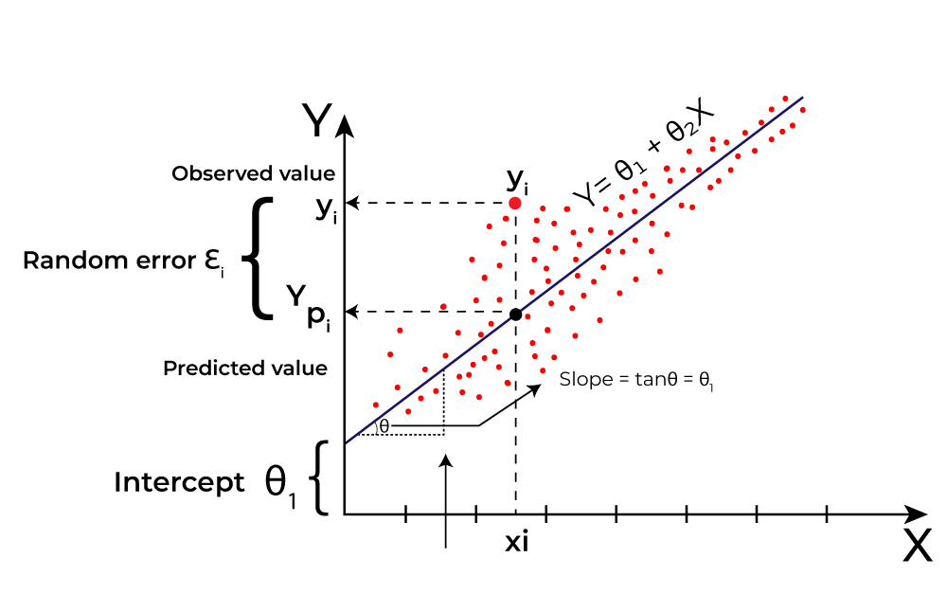
Here Y is called a dependent or target variable and X is called an independent variable also known as the predictor of Y. There are many types of functions or modules that can be used for regression. A linear function is the simplest type of function. Here, X may be a single feature or multiple features representing the problem.
Linear regression performs the task to predict a dependent variable value (y) based on a given independent variable (x)). Hence, the name is Linear Regression. In the figure above, X (input) is the work experience and Y (output) is the salary of a person. The regression line is the best-fit line for our model. We utilize the cost function to compute the best values in order to get the best fit line since different values for weights or the coefficient of lines result in different regression lines.

Evaluation Metrics for Linear Regression: A variety of evaluation measures can be used to determine the strength of any linear regression model. These assessment metrics often give an indication of how well the model is producing the observed outputs.
The most common measurements are:

Mean Square Error (MSE) : Mean Square Error (MSE) is an evaluation metric that calculates the average of the squared differences between the actual and predicted values for all the data points. The difference is squared to ensure that negative and positive differences don’t cancel each other out.
𝑀𝑆𝐸=1𝑛∑𝑖=1𝑛(𝑦𝑖–𝑦𝑖^)2MSE=n1​∑i=1n​(yi​–yi​​)2
Here,
- n is the number of data points.
- yi is the actual or observed value for the ith data point.
- 𝑦𝑖^yi​​ is the predicted value for the ith data point.
MSE is a way to quantify the accuracy of a model’s predictions. MSE is sensitive to outliers as large errors contribute significantly to the overall score.

Mean Absolute Error (MAE): It is an evaluation metric used to calculate the accuracy of a regression model. MAE measures the average absolute difference between the predicted values and actual values.
Mathematically, MAE is expressed as:
𝑀𝐴𝐸=1𝑛∑𝑖=1𝑛∣𝑌𝑖–𝑌𝑖^∣MAE=n1​∑i=1n​∣Yi​–Yi​​∣
Here,
- n is the number of observations
- Yi represents the actual values.
- 𝑌𝑖^Yi​​ represents the predicted values
Lower MAE value indicates better model performance. It is not sensitive to the outliers as we consider absolute differences.

Root Mean Squared Error (RMSE): The square root of the residuals’ variance is the Root Mean Squared Error. It describes how well the observed data points match the expected values, or the model’s absolute fit to the data.

In mathematical notation, it can be expressed as:
𝑅𝑀𝑆𝐸=𝑅𝑆𝑆𝑛=∑𝑖=2𝑛(𝑦𝑖𝑎𝑐𝑡𝑢𝑎𝑙−𝑦𝑖𝑝𝑟𝑒𝑑𝑖𝑐𝑡𝑒𝑑)2𝑛RMSE=nRSS​​=n∑i=2n​(yiactual​−yipredicted​)2​​
Rather than dividing the entire number of data points in the model by the number of degrees of freedom, one must divide the sum of the squared residuals to obtain an unbiased estimate. Then, this figure is referred to as the Residual Standard Error (RSE).
In mathematical notation, it can be expressed as:
𝑅𝑀𝑆𝐸=𝑅𝑆𝑆𝑛=∑𝑖=2𝑛(𝑦𝑖𝑎𝑐𝑡𝑢𝑎𝑙−𝑦𝑖𝑝𝑟𝑒𝑑𝑖𝑐𝑡𝑒𝑑)2(𝑛−2)RMSE=nRSS​​=(n−2)∑i=2n​(yiactual​−yipredicted​)2​​
RSME is not as good of a metric as R-squared. Root Mean Squared Error can fluctuate when the units of the variables vary since its value is dependent on the variables’ units (it is not a normalized measure).

Python Implementation of Linear Regression

Import the necessary libraries:
import pandas as pd
import numpy as np
import matplotlib.pyplot as plt
import matplotlib.axes as ax
from matplotlib.animation import FuncAnimation

Load the dataset and separate input and Target variables
Here is the link for dataset: Dataset Link
url = 'https://data_for_lr.csv'
data = pd.read_csv(url)
print(data)
# Drop the missing values
data = data.dropna()
# training dataset and labels
train_input = np.array(data.x[0:500]).reshape(500, 1)
train_output = np.array(data.y[0:500]).reshape(500, 1)
# valid dataset and labels
test_input = np.array(data.x[500:700]).reshape(199, 1)
test_output = np.array(data.y[500:700]).reshape(199, 1)

Build the Linear Regression Model and Plot the regression line

Steps:
- In forward propagation, Linear regression function Y=mx+c is applied by initially assigning random value of parameter (m & c).
- The we have written the function to finding the cost function i.e the mean

class LinearRegression:
def __init__(self):
self.parameters = {}
def forward_propagation(self, train_input):
m = self.parameters['m']
c = self.parameters['c']
predictions = np.multiply(m, train_input) + c
return predictions
def cost_function(self, predictions, train_output):
cost = np.mean((train_output - predictions) ** 2)
return cost
def backward_propagation(self, train_input, train_output, predictions):
derivatives = {}
df = (predictions-train_output)
# dm= 2/n * mean of (predictions-actual) * input
dm = 2 * np.mean(np.multiply(train_input, df))
# dc = 2/n * mean of (predictions-actual)
dc = 2 * np.mean(df)
derivatives['dm'] = dm
derivatives['dc'] = dc
return derivatives
def update_parameters(self, derivatives, learning_rate):
self.parameters['m'] = self.parameters['m'] - learning_rate * derivatives['dm']
self.parameters['c'] = self.parameters['c'] - learning_rate * derivatives['dc']
def train(self, train_input, train_output, learning_rate, iters):
# Initialize random parameters
self.parameters['m'] = np.random.uniform(0, 1) * -1
self.parameters['c'] = np.random.uniform(0, 1) * -1
# Initialize loss
self.loss = []
# Initialize figure and axis for animation
fig, ax = plt.subplots()
x_vals = np.linspace(min(train_input), max(train_input), 100)
line, = ax.plot(x_vals, self.parameters['m'] * x_vals +
self.parameters['c'], color='red', label='Regression Line')
ax.scatter(train_input, train_output, marker='o',
color='green', label='Training Data')
# Set y-axis limits to exclude negative values
ax.set_ylim(0, max(train_output) + 1)
def update(frame):
# Forward propagation
predictions = self.forward_propagation(train_input)
# Cost function
cost = self.cost_function(predictions, train_output)
# Back propagation
derivatives = self.backward_propagation(
train_input, train_output, predictions)
# Update parameters
self.update_parameters(derivatives, learning_rate)
# Update the regression line
line.set_ydata(self.parameters['m']
* x_vals + self.parameters['c'])
# Append loss and print
self.loss.append(cost)
print("Iteration = {}, Loss = {}".format(frame + 1, cost))
return line,
# Create animation
ani = FuncAnimation(fig, update, frames=iters, interval=200, blit=True)
# Save the animation as a video file (e.g., MP4)
ani.save('linear_regression_A.gif', writer='ffmpeg')
plt.xlabel('Input')
plt.ylabel('Output')
plt.title('Linear Regression')
plt.legend()
plt.show()
return self.parameters, self.loss
Trained The Model For Final Prediction
#Example usage
linear_reg = LinearRegression()
parameters, loss = linear_reg.train(train_input, train_output, 0.0001, 20)
Output:
Iteration = 1, Loss = 9130.407560462196
Iteration = 1, Loss = 1107.1996742908998
Iteration = 1, Loss = 140.31580932842422
Iteration = 1, Loss = 23.795780526084116
Iteration = 2, Loss = 9.753848205147605
Iteration = 3, Loss = 8.061641745006835
Iteration = 4, Loss = 7.8577116490914864
Iteration = 5, Loss = 7.8331350515579015
Iteration = 6, Loss = 7.830172502503967
Iteration = 7, Loss = 7.829814681591015
Iteration = 8, Loss = 7.829770758846183
Iteration = 9, Loss = 7.829764664327399
Iteration = 10, Loss = 7.829763128602258
Iteration = 11, Loss = 7.829762142342088
Iteration = 12, Loss = 7.829761222379141
Iteration = 13, Loss = 7.829760310486438
Iteration = 14, Loss = 7.829759399646989
Iteration = 15, Loss = 7.829758489015161
Iteration = 16, Loss = 7.829757578489033
Iteration = 17, Loss = 7.829756668056319
Iteration = 18, Loss = 7.829755757715535
Iteration = 19, Loss = 7.829754847466484
Iteration = 20, Loss = 7.829753937309139



2.Decision Tree:
Decision Tree is one of the most powerful and popular algorithms. Python Decision-tree algorithm falls under the category of supervised learning algorithms. It works for both continuous as well as categorical output variables. In this article, We are going to implement a Decision tree in Python algorithm on the Balance Scale Weight & Distance Database presented on the UCI. A Decision tree is a tree-like structure that represents a set of decisions and their possible consequences. Each node in the tree represents a decision, and each branch represents an outcome of that decision. The leaves of the tree represent the final decisions or predictions.
Decision trees are created by recursively partitioning the data into smaller and smaller subsets. At each partition, the data is split based on a specific feature, and the split is made in a way that maximizes the information gain.
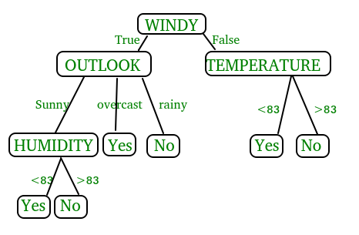
In the above figure, decision tree is a flowchart-like tree structure that is used to make decisions. It consists of Root Node(WINDY), Internal nodes(OUTLOOK, TEMPERATURE), which represent tests on attributes, and leaf nodes, which represent the final decisions. The branches of the tree represent the possible outcomes of the tests.

Key Components of Decision Trees in Python
- Root Node: The decision tree’s starting node, which stands for the complete dataset.
- Branch Nodes: Internal nodes that represent decision points, where the data is split based on a specific attribute.
- Leaf Nodes: Final categorization or prediction-representing terminal nodes.
- Decision Rules: Rules that govern the splitting of data at each branch node.
- Attribute Selection: The process of choosing the most informative attribute for each split.
- Splitting Criteria: Metrics like information gain, entropy, or the Gini Index are used to calculate the optimal split.

Assumptions we make while using Decision tree
- At the beginning, we consider the whole training set as the root.
- Attributes are assumed to be categorical for information gain and for gini index, attributes are assumed to be continuous.
- On the basis of attribute values records are distributed recursively.
- We use statistical methods for ordering attributes as root or internal node
Implementing Decision Tree Using Python:
from sklearn.datasets import load_iris
from sklearn.model_selection import train_test_split
from sklearn.tree import DecisionTreeClassifier
from sklearn.metrics import accuracy_score
# Load the Iris dataset
iris = load_iris()
X = iris.data
y = iris.target
# Split the dataset into training and testing sets
X_train, X_test, y_train, y_test = train_test_split(X, y, test_size=0.2, random_state=42)
# Initialize the decision tree classifier
clf = DecisionTreeClassifier()
# Train the classifier on the training data
clf.fit(X_train, y_train)
# Make predictions on the testing data
y_pred = clf.predict(X_test)
# Calculate the accuracy of the classifier
accuracy = accuracy_score(y_test, y_pred)
print("Accuracy:", accuracy)
In This Example :
- We first import necessary modules from scikit-learn.
- We load the Iris dataset, a popular dataset for classification tasks.
- We split the dataset into training and testing sets using the train test split function.
- We initialize a Decision Tree Classifier.
- We train the classifier on the training data using the fit method.
- We make predictions on the testing data using the predict method.
- Finally, we calculate the accuracy of the classifier using the accuracy score function.

3.Random Forest:
Machine learning, a fascinating blend of computer science and statistics, has witnessed incredible progress, with one standout algorithm being the Random Forest. Random forests or Random Decision Trees is a collaborative team of decision trees that work together to provide a single output. Originating in 2001 through Leo Breiman, Random Forest has become a cornerstone for machine learning enthusiasts. In this article, we will explore the fundamentals and implementation of Random Forest Algorithm.
Random Forest algorithm is a powerful tree learning technique in Machine Learning. It works by creating a number of Decision Trees during the training phase. Each tree is constructed using a random subset of the data set to measure a random subset of features in each partition. This randomness introduces variability among individual trees, reducing the risk of overfitting and improving overall prediction performance. In prediction, the algorithm aggregates the results of all trees, either by voting (for classification tasks) or by averaging (for regression tasks) This collaborative decision-making process, supported by multiple trees with their insights, provides an example stable and precise results. Random forests are widely used for classification and regression functions, which are known for their ability to handle complex data, reduce overfitting, and provide reliable forecasts in different environments.
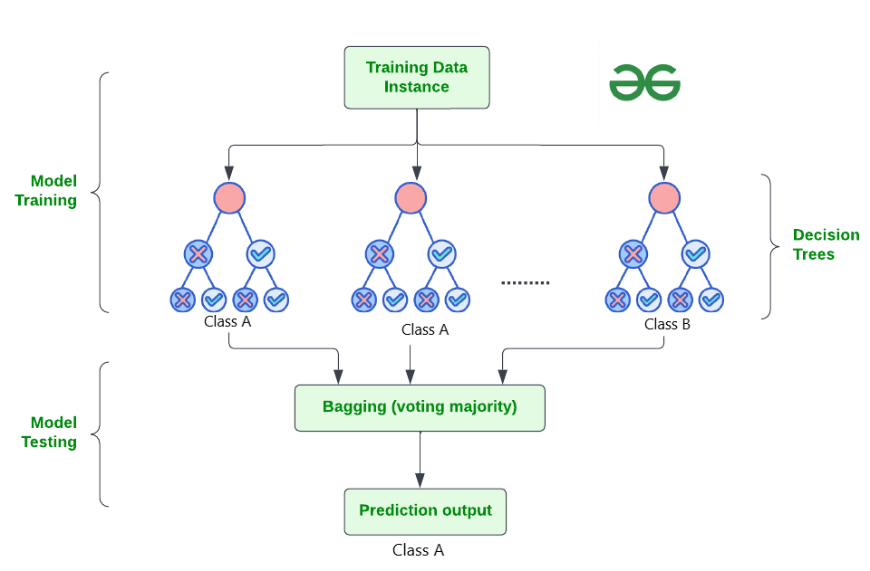

How Does Random Forest Work?
The random Forest algorithm works in several steps which are discussed below–>
- Ensemble of Decision Trees: Random Forest leverages the power of ensemble learning by constructing an army of Decision Trees. These trees are like individual experts, each specializing in a particular aspect of the data. Importantly, they operate independently, minimizing the risk of the model being overly influenced by the nuances of a single tree.
- Random Feature Selection: To ensure that each decision tree in the ensemble brings a unique perspective, Random Forest employs random feature selection. During the training of each tree, a random subset of features is chosen. This randomness ensures that each tree focuses on different aspects of the data, fostering a diverse set of predictors within the ensemble.
- Bootstrap Aggregating or Bagging: The technique of bagging is a cornerstone of Random Forest’s training strategy which involves creating multiple bootstrap samples from the original dataset, allowing instances to be sampled with replacement. This results in different subsets of data for each decision tree, introducing variability in the training process and making the model more robust.
- Decision Making and Voting: When it comes to making predictions, each decision tree in the Random Forest casts its vote. For classification tasks, the final prediction is determined by the mode (most frequent prediction) across all the trees. In regression tasks, the average of the individual tree predictions is taken. This internal voting mechanism ensures a balanced and collective decision-making process.

Key Features of Random Forest
Some of the Key Features of Random Forest are discussed below–>
- High Predictive Accuracy: Imagine Random Forest as a team of decision-making wizards. Each wizard (decision tree) looks at a part of the problem, and together, they weave their insights into a powerful prediction tapestry. This teamwork often results in a more accurate model than what a single wizard could achieve.
- Resistance to Overfitting: Random Forest is like a cool-headed mentor guiding its apprentices (decision trees). Instead of letting each apprentice memorize every detail of their training, it encourages a more well-rounded understanding. This approach helps prevent getting too caught up with the training data which makes the model less prone to overfitting.
- Large Datasets Handling: Dealing with a mountain of data? Random Forest tackles it like a seasoned explorer with a team of helpers (decision trees). Each helper takes on a part of the dataset, ensuring that the expedition is not only thorough but also surprisingly quick.
- Variable Importance Assessment: Think of Random Forest as a detective at a crime scene, figuring out which clues (features) matter the most. It assesses the importance of each clue in solving the case, helping you focus on the key elements that drive predictions.
- Built-in Cross-Validation: Random Forest is like having a personal coach that keeps you in check. As it trains each decision tree, it also sets aside a secret group of cases (out-of-bag) for testing. This built-in validation ensures your model doesn’t just ace the training but also performs well on new challenges.
- Handling Missing Values: Life is full of uncertainties, just like datasets with missing values. Random Forest is the friend who adapts to the situation, making predictions using the information available. It doesn’t get flustered by missing pieces; instead, it focuses on what it can confidently tell us.
- Parallelization for Speed: Random Forest is your time-saving buddy. Picture each decision tree as a worker tackling a piece of a puzzle simultaneously. This parallel approach taps into the power of modern tech, making the whole process faster and more efficient for handling large-scale projects.

Implement Random Forest for Classification :
# Import necessary libraries
import pandas as pd
from sklearn.model_selection import train_test_split
from sklearn.ensemble import RandomForestClassifier
from sklearn.metrics import accuracy_score, classification_report
import warnings
warnings.filterwarnings('ignore')
# Load the Titanic dataset
url = "https://raw.githubusercontent.com/datasciencedojo/datasets/master/titanic.csv"
titanic_data = pd.read_csv(url)
# Drop rows with missing target values
titanic_data = titanic_data.dropna(subset=['Survived'])
# Select relevant features and target variable
X = titanic_data[['Pclass', 'Sex', 'Age', 'SibSp', 'Parch', 'Fare']]
y = titanic_data['Survived']
# Convert categorical variable 'Sex' to numerical using .loc
X.loc[:, 'Sex'] = X['Sex'].map({'female': 0, 'male': 1})
# Handle missing values in the 'Age' column using .loc
X.loc[:, 'Age'].fillna(X['Age'].median(), inplace=True)

# Split the dataset into training and testing sets
X_train, X_test, y_train, y_test = train_test_split(X, y, test_size=0.2, random_state=42)
# Create a Random Forest Classifier
rf_classifier = RandomForestClassifier(n_estimators=100, random_state=42)
# Train the classifier
rf_classifier.fit(X_train, y_train)
# Make predictions on the test set
y_pred = rf_classifier.predict(X_test)
# Evaluate the model
accuracy = accuracy_score(y_test, y_pred)
classification_rep = classification_report(y_test, y_pred)
# Print the results
print(f"Accuracy: {accuracy:.2f}")
print("\nClassification Report:\n", classification_rep)
Output:
Accuracy: 0.80

Classification Report:
precision recall f1-score support

0 0.82 0.85 0.83 105
1 0.77 0.73 0.75 74

accuracy 0.80 179
macro avg 0.79 0.79 0.79 179
weighted avg 0.80 0.80 0.80 179

In the above code, we’re using a Random Forest Classifier to make sense of the Titanic dataset. First, we gather our tools – importing libraries to handle data and evaluate our model. Next, we dive into the Titanic dataset, fixing missing information and choosing important details like a detective solving a mystery. We even teach the computer to understand ‘male’ and ‘female’ by turning them into numbers. Then, we split our dataset into pieces – one part to train our model, and the other to test its newfound skills. Our Random Forest Classifier is like a student, learning from the training set. Once trained, it faces a test – making predictions on the test set. We’re like judges, using a classification report to grade how well our model did.
4. Support Vector Machine (SVM):
Support Vector Machine (SVM) is a powerful machine learning algorithm used for linear or nonlinear classification, regression, and even outlier detection tasks. SVMs can be used for a variety of tasks, such as text classification, image classification, spam detection, handwriting identification, gene expression analysis, face detection, and anomaly detection. SVMs are adaptable and efficient in a variety of applications because they can manage high-dimensional data and nonlinear relationships. SVM algorithms are very effective as we try to find the maximum separating hyperplane between the different classes available in the target feature. Support Vector Machine (SVM) is a supervised machine learning algorithm used for both classification and regression. Though we say regression problems as well it’s best suited for classification. The main objective of the SVM algorithm is to find the optimal hyperplane in an N-dimensional space that can separate the data points in different classes in the feature space. The hyperplane tries that the margin between the closest points of different classes should be as maximum as possible. The dimension of the hyperplane depends upon the number of features. If the number of input features is two, then the hyperplane is just a line. If the number of input features is three, then the hyperplane becomes a 2-D plane. It becomes difficult to imagine when the number of features exceeds three.
Let’s consider two independent variables x₁, x_{2,} and one dependent variable which is either a blue circle or a red circle.
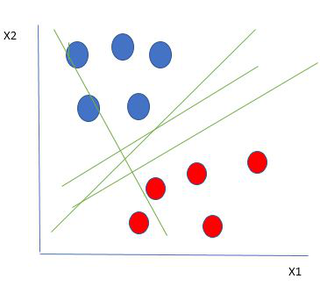
Linearly Separable Data points
From the figure above it’s very clear that there are multiple lines (our hyperplane here is a line because we are considering only two input features x₁, x₂) that segregate our data points or do a classification between red and blue circles. So how do we choose the best line or in general the best hyperplane that segregates our data points?

One reasonable choice as the best hyperplane is the one that represents the largest separation or margin between the two classes.
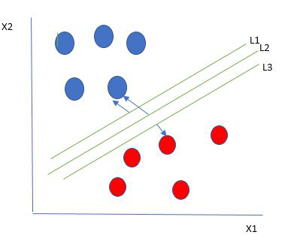
Multiple hyperplanes separate the data from two classes
So we choose the hyperplane whose distance from it to the nearest data point on each side is maximized. If such a hyperplane exists it is known as the maximum-margin hyperplane/hard margin. So from the above figure, we choose L2. Let’s consider a scenario like shown below
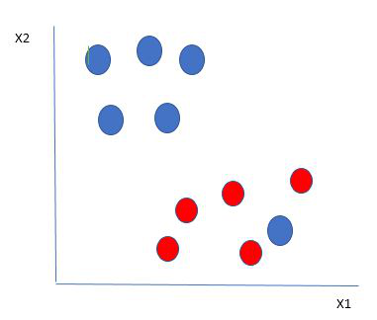
Selecting hyperplane for data with outlier
Here we have one blue ball in the boundary of the red ball. So how does SVM classify the data? It’s simple! The blue ball in the boundary of red ones is an outlier of blue balls. The SVM algorithm has the characteristics to ignore the outlier and finds the best hyperplane that maximizes the margin. SVM is robust to outliers.
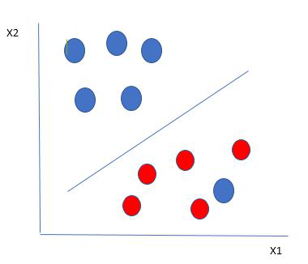
Hyperplane which is the most optimized one
So in this type of data point what SVM does is, finds the maximum margin as done with previous data sets along with that it adds a penalty each time a point crosses the margin. So the margins in these types of cases are called soft margins. When there is a soft margin to the data set, the SVM tries to minimize (1/margin+∧(∑penalty)). Hinge loss is a commonly used penalty. If no violations no hinge loss.If violations hinge loss proportional to the distance of violation.
Till now, we were talking about linearly separable data(the group of blue balls and red balls are separable by a straight line/linear line). What to do if data are not linearly separable?
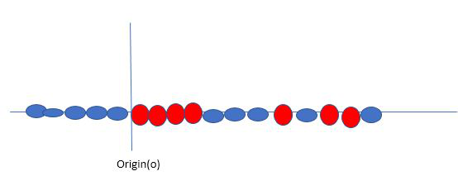
Original 1D dataset for classification
Say, our data is shown in the figure above. SVM solves this by creating a new variable using a kernel. We call a point x_{i} on the line and we create a new variable y_{i} as a function of distance from origin o.so if we plot this we get something like as shown below
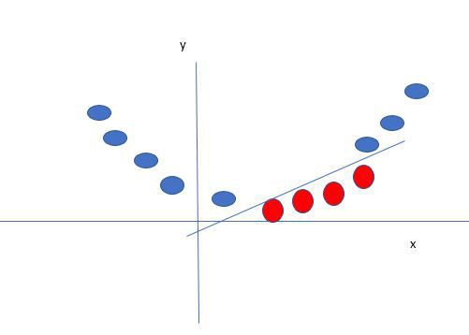
Mapping 1D data to 2D to become able to separate the two classes
In this case, the new variable y is created as a function of distance from the origin. A non-linear function that creates a new variable is referred to as a kernel.

Support Vector Machine Terminology
- Hyperplane: Hyperplane is the decision boundary that is used to separate the data points of different classes in a feature space. In the case of linear classifications, it will be a linear equation i.e. wx+b = 0.
- Support Vectors: Support vectors are the closest data points to the hyperplane, which makes a critical role in deciding the hyperplane and margin.
- Margin: Margin is the distance between the support vector and hyperplane. The main objective of the support vector machine algorithm is to maximize the margin. The wider margin indicates better classification performance.
- Kernel: Kernel is the mathematical function, which is used in SVM to map the original input data points into high-dimensional feature spaces, so, that the hyperplane can be easily found out even if the data points are not linearly separable in the original input space. Some of the common kernel functions are linear, polynomial, radial basis function(RBF), and sigmoid.
- Hard Margin: The maximum-margin hyperplane or the hard margin hyperplane is a hyperplane that properly separates the data points of different categories without any misclassifications.
- Soft Margin: When the data is not perfectly separable or contains outliers, SVM permits a soft margin technique. Each data point has a slack variable introduced by the soft-margin SVM formulation, which softens the strict margin requirement and permits certain misclassifications or violations. It discovers a compromise between increasing the margin and reducing violations.
- C: Margin maximisation and misclassification fines are balanced by the regularisation parameter C in SVM. The penalty for going over the margin or misclassifying data items is decided by it. A stricter penalty is imposed with a greater value of C, which results in a smaller margin and perhaps fewer misclassifications.
- Hinge Loss: A typical loss function in SVMs is hinge loss. It punishes incorrect classifications or margin violations. The objective function in SVM is frequently formed by combining it with the regularisation term.
- Dual Problem: A dual Problem of the optimisation problem that requires locating the Lagrange multipliers related to the support vectors can be used to solve SVM. The dual formulation enables the use of kernel tricks and more effective computing.

SVM implementation in Python
Predict if cancer is Benign or malignant. Using historical data about patients diagnosed with cancer enables doctors to differentiate malignant cases and benign ones are given independent attributes.

Steps
- Load the breast cancer dataset from sklearn.datasets
- Separate input features and target variables.
- Buil and train the SVM classifiers using RBF kernel.
- Plot the scatter plot of the input features.
- Plot the decision boundary.
- Plot the decision boundary
Example:
# Load the important packages
from sklearn.datasets import load_breast_cancer
import matplotlib.pyplot as plt
from sklearn.inspection import DecisionBoundaryDisplay
from sklearn.svm import SVC
# Load the datasets
cancer = load_breast_cancer()
X = cancer.data[:, :2]
y = cancer.target
#Build the model
svm = SVC(kernel="rbf", gamma=0.5, C=1.0)
# Trained the model
svm.fit(X, y)
# Plot Decision Boundary
DecisionBoundaryDisplay.from_estimator(
svm,
X,
response_method="predict",
cmap=plt.cm.Spectral,
alpha=0.8,
xlabel=cancer.feature_names[0],
ylabel=cancer.feature_names[1],
)
# Scatter plot
plt.scatter(X[:, 0], X[:, 1], c=y, s=20, edgecolors="k")
plt.show()
Output:
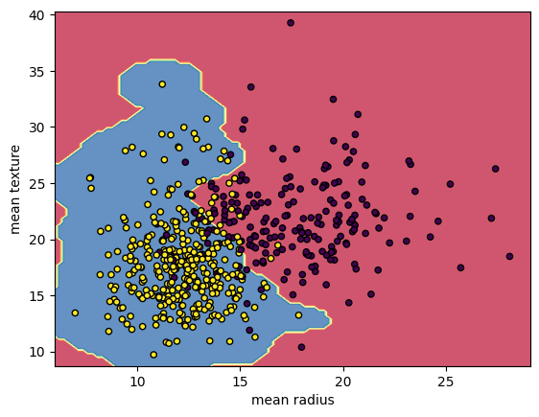
Breast Cancer Classifications with SVM RBF kernel
5.Naïve Bayes:
A Naive Bayes classifiers, a family of algorithms based on Bayes’ Theorem. Despite the “naive” assumption of feature independence, these classifiers are widely utilized for their simplicity and efficiency in machine learning. The article delves into theory, implementation, and applications, shedding light on their practical utility despite oversimplified assumptions.

What is Naive Bayes Classifiers?
Naive Bayes classifiers are a collection of classification algorithms based on Bayes’ Theorem. It is not a single algorithm but a family of algorithms where all of them share a common principle, i.e. every pair of features being classified is independent of each other. To start with, let us consider a dataset.
One of the most simple and effective classification algorithms, the Naïve Bayes classifier aids in the rapid development of machine learning models with rapid prediction capabilities.
Naïve Bayes algorithm is used for classification problems. It is highly used in text classification. In text classification tasks, data contains high dimension (as each word represent one feature in the data). It is used in spam filtering, sentiment detection, rating classification etc. The advantage of using naïve Bayes is its speed. It is fast and making prediction is easy with high dimension of data.This model predicts the probability of an instance belongs to a class with a given set of feature value. It is a probabilistic classifier. It is because it assumes that one feature in the model is independent of existence of another feature. In other words, each feature contributes to the predictions with no relation between each other. In real world, this condition satisfies rarely. It uses Bayes theorem in the algorithm for training and prediction

Why it is Called Naive Bayes?
The “Naive” part of the name indicates the simplifying assumption made by the Naïve Bayes classifier. The classifier assumes that the features used to describe an observation are conditionally independent, given the class label. The “Bayes” part of the name refers to Reverend Thomas Bayes, an 18th-century statistician and theologian who formulated Bayes’ theorem.
Consider a fictional dataset that describes the weather conditions for playing a game of golf. Given the weather conditions, each tuple classifies the conditions as fit(“Yes”) or unfit(“No”) for playing golf.Here is a tabular representation of our dataset.
The assumptions made by Naive Bayes are not generally correct in real-world situations. In-fact, the independence assumption is never correct but often works well in practice.Now, before moving to the formula for Naive Bayes, it is important to know about Bayes’ theorem.

Bayes’ Theorem
Bayes’ Theorem finds the probability of an event occurring given the probability of another event that has already occurred. Bayes’ theorem is stated mathematically as the following equation:
P(A∣B)=P(B)P(B∣A)P(A)​
where A and B are events and P(B) ≠ 0
- Basically, we are trying to find probability of event A, given the event B is true. Event B is also termed as evidence.
- P(A) is the priori of A (the prior probability, i.e. Probability of event before evidence is seen). The evidence is an attribute value of an unknown instance(here, it is event B).
- P(B) is Marginal Probability: Probability of Evidence.
- P(A|B) is a posteriori probability of B, i.e. probability of event after evidence is seen.
- P(B|A) is Likelihood probability i.e the likelihood that a hypothesis will come true based on the evidence.

Naive Bayes implementation in Python
# load the iris dataset
from sklearn.datasets import load_iris
iris = load_iris()
# store the feature matrix (X) and response vector (y)
X = iris.data
y = iris.target
# splitting X and y into training and testing sets
from sklearn.model_selection import train_test_split
X_train, X_test, y_train, y_test = train_test_split(X, y, test_size=0.4, random_state=1)
# training the model on training set
from sklearn.naive_bayes import GaussianNB
gnb = GaussianNB()
gnb.fit(X_train, y_train)
# making predictions on the testing set
y_pred = gnb.predict(X_test)
# comparing actual response values (y_test) with predicted response values (y_pred)
from sklearn import metrics
print("Gaussian Naive Bayes model accuracy(in %):", metrics.accuracy_score(y_test, y_pred)*100)
OUTPUT: Gaussian Naive Bayes model accuracy(in %): 95.0

6. K-Nearest Neighbors (KNN):
The K-Nearest Neighbors (KNN) algorithm is a supervised machine learning method employed to tackle classification and regression problems. Evelyn Fix and Joseph Hodges developed this algorithm in 1951, which was subsequently expanded by Thomas Cover. The article explores the fundamentals, workings, and implementation of the KNN algorithm.

What is the K-Nearest Neighbors Algorithm?
KNN is one of the most basic yet essential classification algorithms in machine learning. It belongs to the supervised learning domain and finds intense application in pattern recognition, data mining, and intrusion detection.
It is widely disposable in real-life scenarios since it is non-parametric, meaning it does not make any underlying assumptions about the distribution of data (as opposed to other algorithms such as GMM, which assume a Gaussian distribution of the given data). We are given some prior data (also called training data), which classifies coordinates into groups identified by an attribute.
As an example, consider the following table of data points containing two features:


KNN Algorithm working visualization
Now, given another set of data points (also called testing data), allocate these points to a group by analyzing the training set. Note that the unclassified points are marked as ‘White’

Why do we need a KNN algorithm?
(KNN) algorithm is a versatile and widely used machine learning algorithm that is primarily used for its simplicity and ease of implementation. It does not require any assumptions about the underlying data distribution. It can also handle both numerical and categorical data, making it a flexible choice for various types of datasets in classification and regression tasks. It is a non-parametric method that makes predictions based on the similarity of data points in a given dataset. KNN is less sensitive to outliers compared to other algorithms.
The KNN algorithm works by finding the K nearest neighbors to a given data point based on a distance metric, such as Euclidean distance. The class or value of the data point is then determined by the majority vote or average of the K neighbors. This approach allows the algorithm to adapt to different patterns and make predictions based on the local structure of the data.

Distance Metrics Used in KNN Algorithm
As we know that the KNN algorithm helps us identify the nearest points or the groups for a query point. But to determine the closest groups or the nearest points for a query point we need some metric. For this purpose, we use below distance metrics:

Euclidean Distance
This is nothing but the cartesian distance between the two points which are in the plane/hyperplane. Euclidean distance can also be visualized as the length of the straight line that joins the two points which are into consideration. This metric helps us calculate the net displacement done between the two states of an object.

Manhattan Distance
Manhattan Distance metric is generally used when we are interested in the total distance traveled by the object instead of the displacement. This metric is calculated by summing the absolute difference between the coordinates of the points in n-dimensions.

Minkowski Distance
We can say that the Euclidean, as well as the Manhattan distance, are special cases of the Minkowski distance.
From the formula above we can say that when p = 2 then it is the same as the formula for the Euclidean distance and when p = 1 then we obtain the formula for the Manhattan distance.
The above-discussed metrics are most common while dealing with a Machine Learning problem but there are other distance metrics as well like Hamming Distance which come in handy while dealing with problems that require overlapping comparisons between two vectors whose contents can be Boolean as well as string values.

How to choose the value of k for KNN Algorithm?
The value of k is very crucial in the KNN algorithm to define the number of neighbors in the algorithm. The value of k in the k-nearest neighbors (k-NN) algorithm should be chosen based on the input data. If the input data has more outliers or noise, a higher value of k would be better. It is recommended to choose an odd value for k to avoid ties in classification. Cross-validation methods can help in selecting the best k value for the given dataset.

Workings of KNN algorithm
Thе K-Nearest Neighbors (KNN) algorithm operates on the principle of similarity, where it predicts the label or value of a new data point by considering the labels or values of its K nearest neighbors in the training dataset.

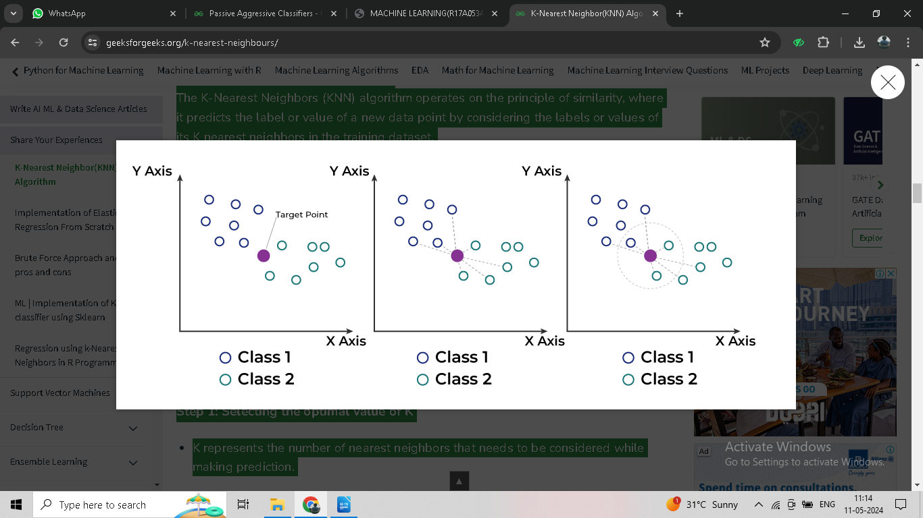

Step-by-Step explanation of how KNN works is discussed below:

Step 1: Selecting the optimal value of K
- K represents the number of nearest neighbors that needs to be considered while making prediction.

Step 2: Calculating distance
- To measure the similarity between target and training data points, Euclidean distance is used. Distance is calculated between each of the data points in the dataset and target point.

Step 3: Finding Nearest Neighbors
- The k data points with the smallest distances to the target point are the nearest neighbors.

Step 4: Voting for Classification or Taking Average for Regression
- In the classification problem, the class labels of are determined by performing majority voting. The class with the most occurrences among the neighbors becomes the predicted class for the target data point.
- In the regression problem, the class label is calculated by taking average of the target values of K nearest neighbors. The calculated average value becomes the predicted output for the target data point.
Let X be the training dataset with n data points, where each data point is represented by a d-dimensional feature vector and Y be the corresponding labels or values for each data point in X. Given a new data point x, the algorithm calculates the distance between x and each data point in X using a distance metric, such as Euclidean distance:
The algorithm selects the K data points from X that have the shortest distances to x. For classification tasks, the algorithm assigns the label y that is most frequent among the K nearest neighbors to x. For regression tasks, the algorithm calculates the average or weighted average of the values y of the K nearest neighbors and assigns it as the predicted value for x.

Advantages of the KNN Algorithm
- Easy to implement as the complexity of the algorithm is not that high.
- Adapts Easily – As per the working of the KNN algorithm it stores all the data in memory storage and hence whenever a new example or data point is added then the algorithm adjusts itself as per that new example and has its contribution to the future predictions as well.
- Few Hyper parameters – The only parameters which are required in the training of a KNN algorithm are the value of k and the choice of the distance metric which we would like to choose from our evaluation metric.

Disadvantages of the KNN Algorithm
- Does not scale – As we have heard about this that the KNN algorithm is also considered a Lazy Algorithm. The main significance of this term is that this takes lots of computing power as well as data storage. This makes this algorithm both time-consuming and resource exhausting.
- Curse of Dimensionality – There is a term known as the peaking phenomenon according to this the KNN algorithm is affected by the curse of dimensionality which implies the algorithm faces a hard time classifying the data points properly when the dimensionality is too high.
- Prone to Over fitting – As the algorithm is affected due to the curse of dimensionality it is prone to the problem of overfitting as well. Hence generally feature selection as well as dimensionality reduction techniques are applied to deal with this problem.
7. XGBOOST Algorithm:
XGBoost is an optimized distributed gradient boosting library designed for efficient and scalable training of machine learning models. It is an ensemble learning method that combines the predictions of multiple weak models to produce a stronger prediction. XGBoost stands for “Extreme Gradient Boosting” and it has become one of the most popular and widely used machine learning algorithms due to its ability to handle large datasets and its ability to achieve state-of-the-art performance in many machine learning tasks such as classification and regression.
One of the key features of XGBoost is its efficient handling of missing values, which allows it to handle real-world data with missing values without requiring significant pre-processing. Additionally, XGBoost has built-in support for parallel processing, making it possible to train models on large datasets in a reasonable amount of time.
XGBoost can be used in a variety of applications, including Kaggle competitions, recommendation systems, and click-through rate prediction, among others. It is also highly customizable and allows for fine-tuning of various model parameters to optimize performance.
XgBoost stands for Extreme Gradient Boosting, which was proposed by the researchers at the University of Washington. It is a library written in C++ which optimizes the training for Gradient Boosting.
Before understanding the XGBoost, we first need to understand the trees especially the decision tree:

Decision Tree:
A Decision tree is a flowchart-like tree structure, where each internal node denotes a test on an attribute, each branch represents an outcome of the test, and each leaf node (terminal node) holds a class label.
A tree can be “learned” by splitting the source set into subsets based on an attribute value test. This process is repeated on each derived subset in a recursive manner called recursive partitioning. The recursion is completed when the subset at a node all has the same value of the target variable, or when splitting no longer adds value to the predictions.

Bagging:
A Bagging classifier is an ensemble meta-estimator that fits base classifiers each on random subsets of the original dataset and then aggregate their individual predictions (either by voting or by averaging) to form a final prediction. Such a meta-estimator can typically be used as a way to reduce the variance of a black-box estimator (e.g., a decision tree), by introducing randomization into its construction procedure and then making an ensemble out of it.
Each base classifier is trained in parallel with a training set which is generated by randomly drawing, with replacement, N examples(or data) from the original training dataset, where N is the size of the original training set. The training set for each of the base classifiers is independent of each other. Many of the original data may be repeated in the resulting training set while others may be left out.
Bagging reduces overfitting (variance) by averaging or voting, however, this leads to an increase in bias, which is compensated by the reduction in variance though.

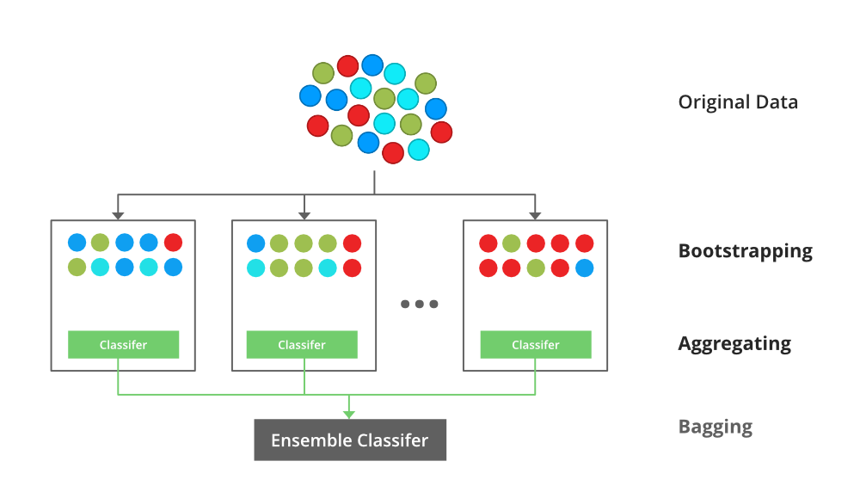

Random Forest:
Every decision tree has high variance, but when we combine all of them together in parallel then the resultant variance is low as each decision tree gets perfectly trained on that particular sample data and hence the output doesn’t depend on one decision tree but multiple decision trees. In the case of a classification problem, the final output is taken by using the majority voting classifier. In the case of a regression problem, the final output is the mean of all the outputs. This part is Aggregation.
The basic idea behind this is to combine multiple decision trees in determining the final output rather than relying on individual decision trees.rRandom Forest has multiple decision trees as base learning models. We randomly perform row sampling and feature sampling from the dataset forming sample datasets for every model. This part is called Bootstrap.

Boosting:
Boosting is an ensemble modelling, technique that attempts to build a strong classifier from the number of weak classifiers. It is done by building a model by using weak models in series. Firstly, a model is built from the training data. Then the second model is built which tries to correct the errors present in the first model. This procedure is continued and models are added until either the complete training data set is predicted correctly or the maximum number of models are added.

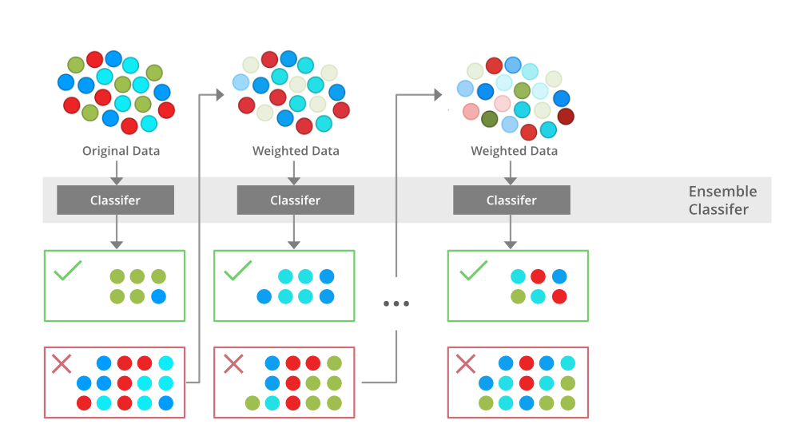

Gradient Boosting
Gradient Boosting is a popular boosting algorithm. In gradient boosting, each predictor corrects its predecessor’s error. In contrast to Adaboost, the weights of the training instances are not tweaked, instead, each predictor is trained using the residual errors of predecessor as labels.
There is a technique called the Gradient Boosted Trees whose base learner is CART (Classification and Regression Trees).

XGBoost
XGBoost is an implementation of Gradient Boosted decision trees. XGBoost models majorly dominate in many Kaggle Competitions.
In this algorithm, decision trees are created in sequential form. Weights play an important role in XGBoost. Weights are assigned to all the independent variables which are then fed into the decision tree which predicts results. The weight of variables predicted wrong by the tree is increased and these variables are then fed to the second decision tree. These individual classifiers/predictors then ensemble to give a strong and more precise model. It can work on regression, classification, ranking, and user-defined prediction problems.

5.2 Sample Code:
Views.py
from django.shortcuts import render
from django.template import RequestContext
from django.contrib import messages
import pymysql
from django.http import HttpResponse
from django.core.files.storage import FileSystemStorage
import os
import random
import io
import base64
import matplotlib.pyplot as plt
from sklearn.metrics import accuracy_score
from sklearn.model_selection import train_test_split
from sklearn import svm
import pandas as pd
from sklearn.metrics import f1_score
from sklearn.metrics import recall_score
from sklearn.metrics import precision_score
import numpy as np
from sklearn.metrics import confusion_matrix

from nltk.corpus import stopwords
import nltk
from sklearn.neighbors import KNeighborsClassifier
from sklearn.naive_bayes import GaussianNB
from sklearn.feature_extraction.text import TfidfVectorizer #loading tfidf vector
from sklearn.ensemble import VotingClassifier
import pickle
import seaborn as sns

global username, X_train, X_test, y_train, y_test, X, Y, ensemble_classifier, img_b64
global accuracy, precision, recall, fscore, vectorizer
stop_words = set(stopwords.words('english'))

def PredictAction(request):
if request.method == 'POST':
global ensemble_classifier, vectorizer
myfile = request.FILES['t1']
name = request.FILES['t1'].name
if os.path.exists("VulnerApp/static/testData.csv"):
os.remove("VulnerApp/static/testData.csv")
fs = FileSystemStorage()
filename = fs.save('VulnerApp/static/testData.csv', myfile)
df = pd.read_csv('VulnerApp/static/testData.csv')
temp = df.values
X = vectorizer.transform(df['Test_data'].astype('U')).toarray()
predict = ensemble_classifier.predict(X)
output = '<table border="1" align="center" width="100%" ><tr><th><font size="" color="black">Test Data</th>'
output += '<th><font size="" color="black">Predicted Vulnerability</th></tr>'
for i in range(len(predict)):
if predict[i] == 0:
status = "No Vulnerability"
if predict[i] == 1:
status = "SQL Injection"
if predict[i] == 2:
status = "Cross Site Scripting/RFI"
out = str(temp[i,0])
out = out.replace("<","")
out = out.replace(">","")
output+='<tr><td><font size="" color="black">'+out+'</td>'
output+='<td><font size="" color="black">'+status+'</td></tr>'
output+="</table><br/><br/><br/><br/><br/><br/>"
context= {'data':output}
return render(request, 'UserScreen.html', context)

def UploadAction(request):
if request.method == 'POST':
global X_train, X_test, y_train, y_test, X, Y, vectorizer
myfile = request.FILES['t1']
name = request.FILES['t1'].name
if os.path.exists("VulnerApp/static/Data.csv"):
os.remove("VulnerApp/static/Data.csv")
fs = FileSystemStorage()
filename = fs.save('VulnerApp/static/Data.csv', myfile)
df = pd.read_csv('VulnerApp/static/Data.csv')
df['Label'] = df['Label'].astype(str).astype(int)
vectorizer = TfidfVectorizer(stop_words=stop_words, use_idf=True, smooth_idf=False, norm=None, decode_error='replace', max_features=300)
X = vectorizer.fit_transform(df['Sentence'].astype('U')).toarray()
temp = pd.DataFrame(X, columns=vectorizer.get_feature_names())
Y = df['Label'].ravel()
indices = np.arange(X.shape[0])
np.random.shuffle(indices)
X = X[indices]
Y = Y[indices]
X_train, X_test, y_train, y_test = train_test_split(X, Y, test_size = 0.1)
output = "Dataset Loading & Processing Completed<br/>"
output += "Dataset Length : "+str(len(X))+"<br/>"
output += "Splitted Training Length : "+str(len(X_train))+"<br/>"
output += "Splitted Test Length : "+str(len(X_test))+"<br/>"
output += "<br/><br/>Features Vector<br/><br/>"+str(temp)+"<br/><br/>"
context= {'data': output}
return render(request, 'Upload.html', context)

def calculateMetrics(algorithm, predict, y_test):
global accuracy, precision, recall, fscore, img_b64
a = accuracy_score(y_test,predict)*100
p = precision_score(y_test, predict,average='macro') * 100
r = recall_score(y_test, predict,average='macro') * 100
f = f1_score(y_test, predict,average='macro') * 100
accuracy.append(a)
precision.append(p)
recall.append(r)
fscore.append(f)
labels = ['No Vulnerability', 'SQL Injection', 'Cross Site Scripting/RFI']
conf_matrix = confusion_matrix(y_test, predict)
plt.figure(figsize =(6, 3))
ax = sns.heatmap(conf_matrix, xticklabels = labels, yticklabels = labels, annot = True, cmap="viridis" ,fmt ="g");
ax.set_ylim([0,len(labels)])
plt.title(algorithm+" Confusion matrix")
plt.ylabel('True class')
plt.xlabel('Predicted class')
#plt.tight_layout()
buf = io.BytesIO()
plt.savefig(buf, format='png', bbox_inches='tight')
plt.close()
img_b64 = base64.b64encode(buf.getvalue()).decode()

def RunEnsemble(request):
if request.method == 'GET':
global accuracy, precision, recall, fscore, X_train, X_test, y_train, y_test, ensemble_classifier
accuracy = []
precision = []
recall = []
fscore = []
nb_cls = GaussianNB()
svm_cls = svm.SVC()
knn_cls = KNeighborsClassifier(n_neighbors=2)
if os.path.exists("model/ensemble.pckl"):
f = open('model/ensemble.pckl', 'rb')
ensemble_classifier = pickle.load(f)
f.close()
else:
#creating estimator with list of classifiers object such as KNN< SVM and Naive Bayes
estimators = [('nb', nb_cls), ('svm', svm_cls), ('knn', knn_cls)]
#training voting classifier as stack classifier by giving stack of 3 different classifiers
ensemble_classifier = VotingClassifier(estimators = estimators)
#now trained classifier on training data
ensemble_classifier.fit(X_train, y_train)
f = open('model/ensemble.pckl', 'wb')
pickle.dump(ensemble_classifier, f)
f.close()
X_test = X_test[0:2000]
y_test = y_test[0:2000]
#performing prediction on test data using ensemble classifier
predict = ensemble_classifier.predict(X_test)
calculateMetrics("Ensemble Classifier", predict, y_test)
algorithms = ['Ensemble Classifier']
output = '<table border="1" align="center" width="100%" ><tr><th><font size="" color="black">Algorithm Name</th>'
output += '<th><font size="" color="black">Accuracy</th><th><font size="" color="black">Precision</th>'
output += '<th><font size="" color="black">Recall</th><th><font size="" color="black">FScore</th></tr>'
for i in range(len(algorithms)):
output+='<tr><td><font size="" color="black">'+algorithms[i]+'</td>'
output+='<td><font size="" color="black">'+str(accuracy[i])+'</td>'
output+='<td><font size="" color="black">'+str(precision[i])+'</td>'
output+='<td><font size="" color="black">'+str(recall[i])+'</td>'
output+='<td><font size="" color="black">'+str(fscore[i])+'</td></tr>'
output+="</table><br/><br/><br/><br/><br/><br/>"
context= {'data':output}
return render(request, 'UserScreen.html', context)

def Graph(request):
if request.method == 'GET':
global img_b64
context= {'data': img_b64}
return render(request, 'ViewGraph.html', context)

def Predict(request):
if request.method == 'GET':
return render(request, 'Predict.html', {})

def Upload(request):
if request.method == 'GET':
return render(request, 'Upload.html', {})

def index(request):
if request.method == 'GET':
return render(request, 'index.html', {})

def Login(request):
if request.method == 'GET':
return render(request, 'Login.html', {})

def Register(request):
if request.method == 'GET':
return render(request, 'Register.html', {})

def UserLogin(request):
if request.method == 'POST':
global username
username = request.POST.get('username', False)
password = request.POST.get('password', False)
status = 'none'
con = pymysql.connect(host='127.0.0.1',port = 3306,user = 'root', password = 'root', database = 'VulnerDB',charset='utf8')
with con:
cur = con.cursor()
cur.execute("select * FROM register")
rows = cur.fetchall()
for row in rows:
if row[0] == username and row[1] == password:
status = 'success'
break
if status == 'success':
context= {'data':'Welcome '+username}
return render(request, 'UserScreen.html', context)
else:
context= {'data':'Invalid login details'}
return render(request, 'Login.html', context)

def Signup(request):
if request.method == 'POST':
username = request.POST.get('username', False)
password = request.POST.get('password', False)
contact = request.POST.get('contact', False)
email = request.POST.get('email', False)
address = request.POST.get('address', False)
status = "none"
con = pymysql.connect(host='127.0.0.1',port = 3306,user = 'root', password = 'root', database = 'VulnerDB',charset='utf8')
with con:
cur = con.cursor()
cur.execute("select username FROM register where username='"+username+"'")
rows = cur.fetchall()
if len(rows) > 0:
status = username+" already exists"
if status == "none":
db_connection = pymysql.connect(host='127.0.0.1',port = 3306,user = 'root', password = 'root', database = 'VulnerDB',charset='utf8')
db_cursor = db_connection.cursor()
student_sql_query = "INSERT INTO register(username,password,contact,email,address) VALUES('"+username+"','"+password+"','"+contact+"','"+email+"','"+address+"')"
db_cursor.execute(student_sql_query)
db_connection.commit()
print(db_cursor.rowcount, "Record Inserted")
if db_cursor.rowcount == 1:
context= {'data':'Signup Process Completed'}
return render(request, 'Register.html', context)
else:
context= {'data':'Error in signup process'}
return render(request, 'Register.html', context)
else:
context= {'data': status}
return render(request, 'Register.html', context)
6. TESTING
Implementation and Testing:
Implementation is one of the most important tasks in project is the phase in which one has to be cautions because all the efforts undertaken during the project will be very interactive. Implementation is the most crucial stage in achieving successful system and giving the users confidence that the new system is workable and effective. Each program is tested individually at the time of development using the sample data and has verified that these programs link together in the way specified in the program specification. The computer system and its environment are tested to the satisfaction of the user.
Implementation
The implementation phase is less creative than system design. It is primarily concerned with user training, and file conversion. The system may be requiring extensive user training. The initial parameters of the system should be modifies as a result of a programming. A simple operating procedure is provided so that the user can understand the different functions clearly and quickly. The different reports can be obtained either on the inkjet or dot matrix printer, which is available at the disposal of the user. The proposed system is very easy to implement. In general implementation is used to mean the process of converting a new or revised system design into an operational one.

Testing
Testing is the process where the test data is prepared and is used for testing the modules individually and later the validation given for the fields. Then the system testing takes place which makes sure that all components of the system property functions as a unit. The test data should be chosen such that it passed through all possible condition. Actually testing is the state of implementation which aimed at ensuring that the system works accurately and efficiently before the actual operation commence. The following is the description of the testing strategies, which were carried out during the testing period.
System Testing
Testing has become an System integral part of any system or project especially in the field of information technology. The importance of testing is a method of justifying, if one is ready to move further, be it to be check if one is capable to with stand the rigors of a particular situation cannot be underplayed and that is why testing before development is so critical. When the software is developed before it is given to user to user the software must be tested whether it is solving the purpose for which it is developed. This testing involves various types through which one can ensure the software is reliable. The program was tested logically and pattern of execution of the program for a set of data are repeated. Thus the code was exhaustively checked for all possible correct data and the outcomes were also checked.
Module Testing
To locate errors, each module is tested individually. This enables us to detect error and correct it without affecting any other modules. Whenever the program is not satisfying the required function, it must be corrected to get the required result. Thus all the modules are individually tested from bottom up starting with the smallest and lowest modules and proceeding to the next level. Each module in the system is tested separately. For example the job classification module is tested separately. This module is tested with different job and its approximate execution time and the result of the test is compared with the results that are prepared manually. The comparison shows that the results proposed system works efficiently than the existing system. Each module in the system is tested separately. In this system the resource classification and job scheduling modules are tested separately and their corresponding results are obtained which reduces the process waiting time.
Integration Testing
After the module testing, the integration testing is applied. When linking the modules there may be chance for errors to occur, these errors are corrected by using this testing. In this system all modules are connected and tested. The testing results are very correct. Thus the mapping of jobs with resources is done correctly by the system.
Acceptance Testing
When that user fined no major problems with its accuracy the system passers through a final acceptance test. This test confirms that the system needs the original goals, objectives and requirements established during analysis without actual execution which elimination wastage of time and money acceptance tests on the shoulders of users and management, it is finally acceptable and ready for the operation.

Test  Case  ID | Test  case  Name | TestCase  Desc. | Step | Expected | Actual | Test  Case  Status | Test  Case  Priority
01 | User Register | Verify the  User Register or not | If the  User May Not be Register | We cannot do the further operations | We Can do further operations | High | High
02 | User Login | Verify the  User Login or not | If the  User May Not be Login | We cannot do the further operations | We Can do further operations | High | High
03 | Load Dataset | Verify The Load Dataset done or not | If The Load Dataset may not done | We cannot do the further operations | We Can do further operations | High | High
04 | Run Ensemble Algorithms | Verify The Run Ensemble Algorithms done or not | If The Run Ensemble Algorithms may not done | We cannot do the further operations | We Can do further operations | High | High
05 | Matrix Graph | Verify The Matrix Graph done or not | If The Matrix Graph may not done | We cannot do the further operations | We Can do further operations | High | High
06 | Predict Vulnerability | Verify The Predict Vulnerability done or not | If The Predict Vulnerability may not done | We cannot do the further operations | We Can do further operations | High | High

7. SCREEN SHOTS:
To run project install python 3.7 and then install MYSQL database and then copy content from DB.txt file and paste in MYSQL to create database. Now double click on ‘installNLTK.bat’ file to download NLTK and once click then window will appear in that window click on “Download’ button to download all packages and once downloaded then window will turn to green colour and then close the window
To run project install python 3.7 and then install MYSQL database and then copy content from DB.txt file and paste in MYSQL to create database. Now double click on ‘installNLTK.bat’ file to download NLTK and once click then window will appear in that window click on “Download’ button to download all packages and once downloaded then window will turn to green colour and then close the window
Now double click on ‘run.bat’ file to start python DJANGO web server and get below screen
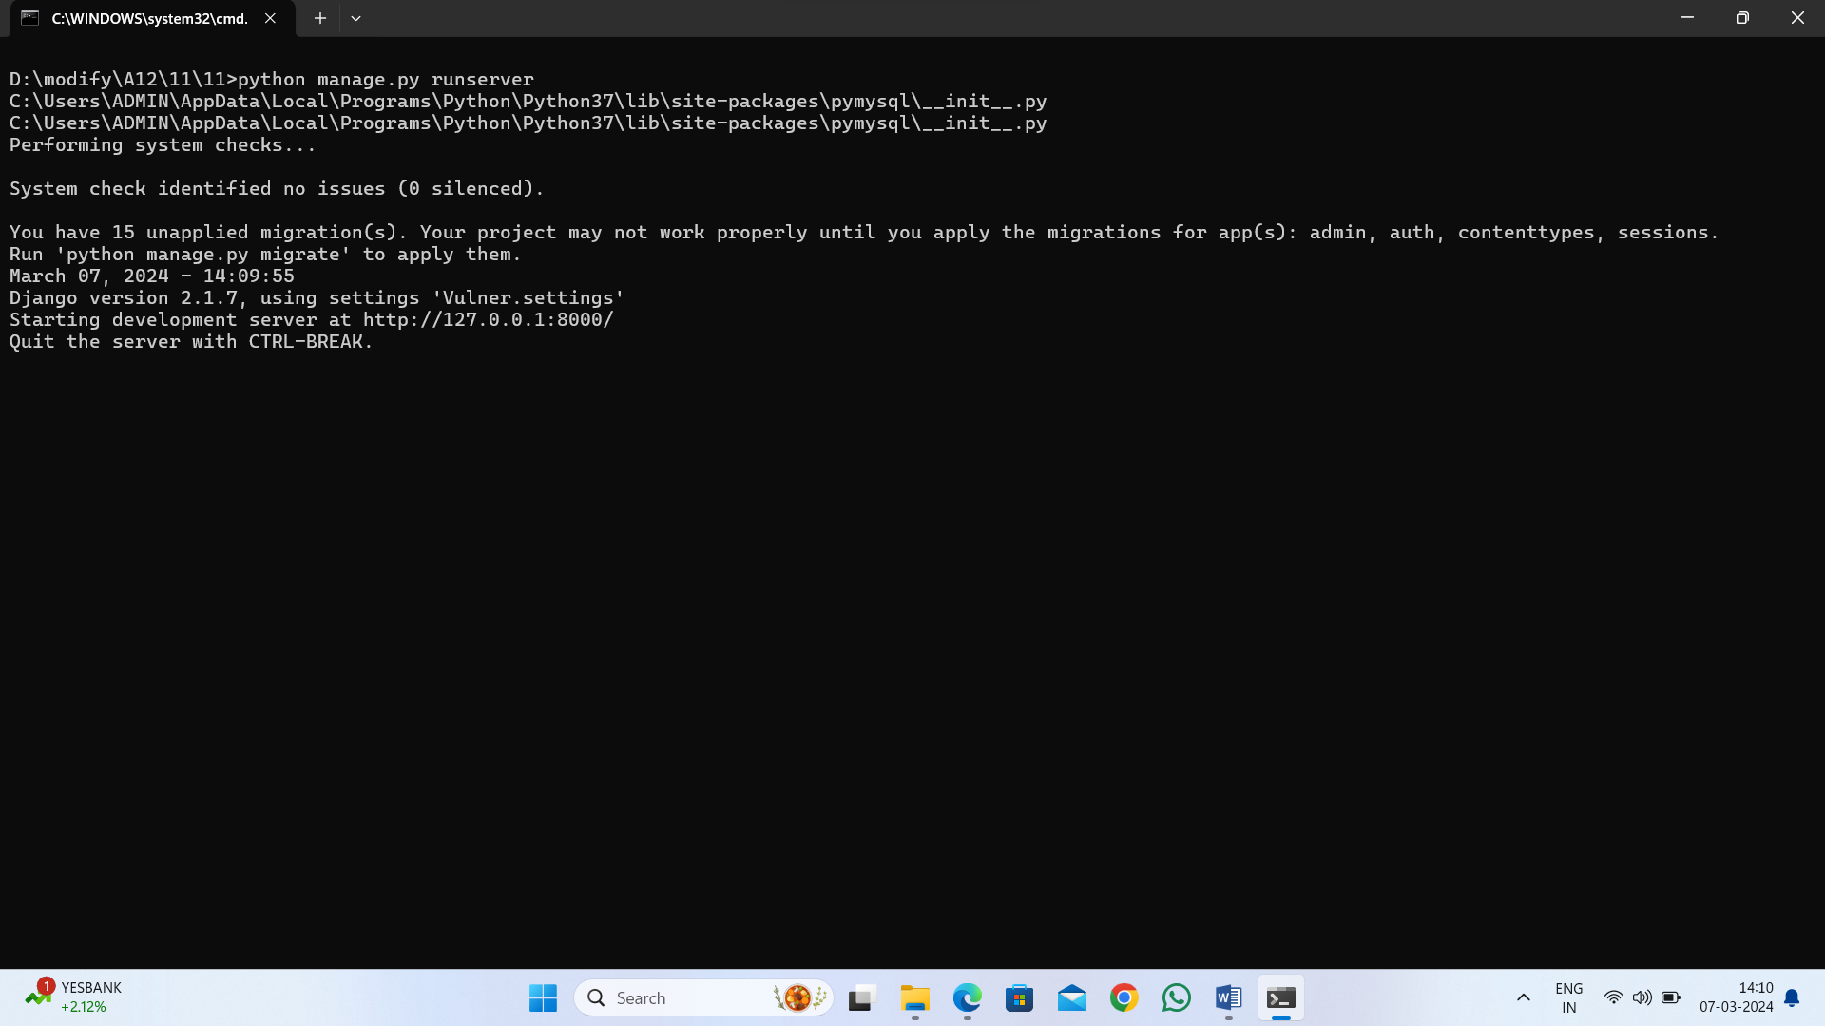
In above screen python web server started and now open browser and enter URL as http://127.0.0.1:8000/index.html and then press enter key to get below page
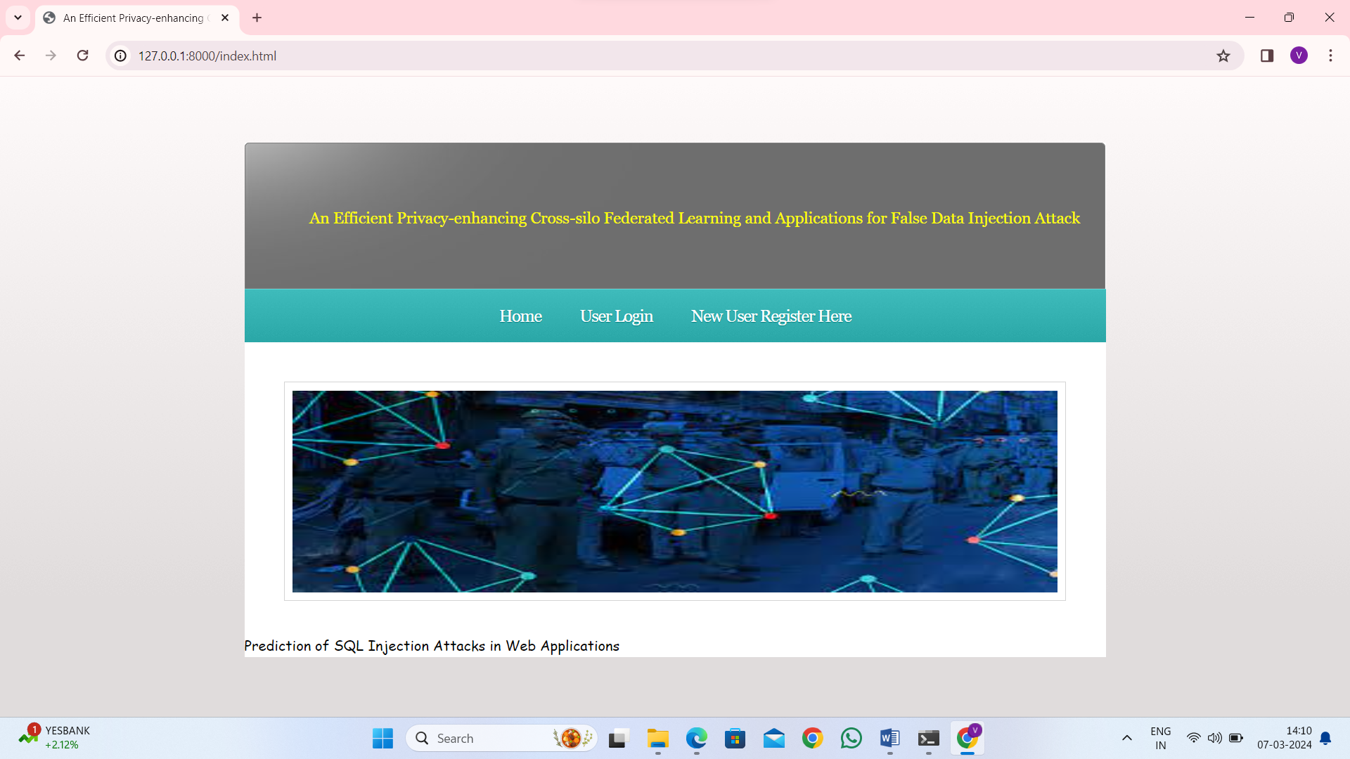
In above screen click on ‘New User Register Here’ link to get below sign up page
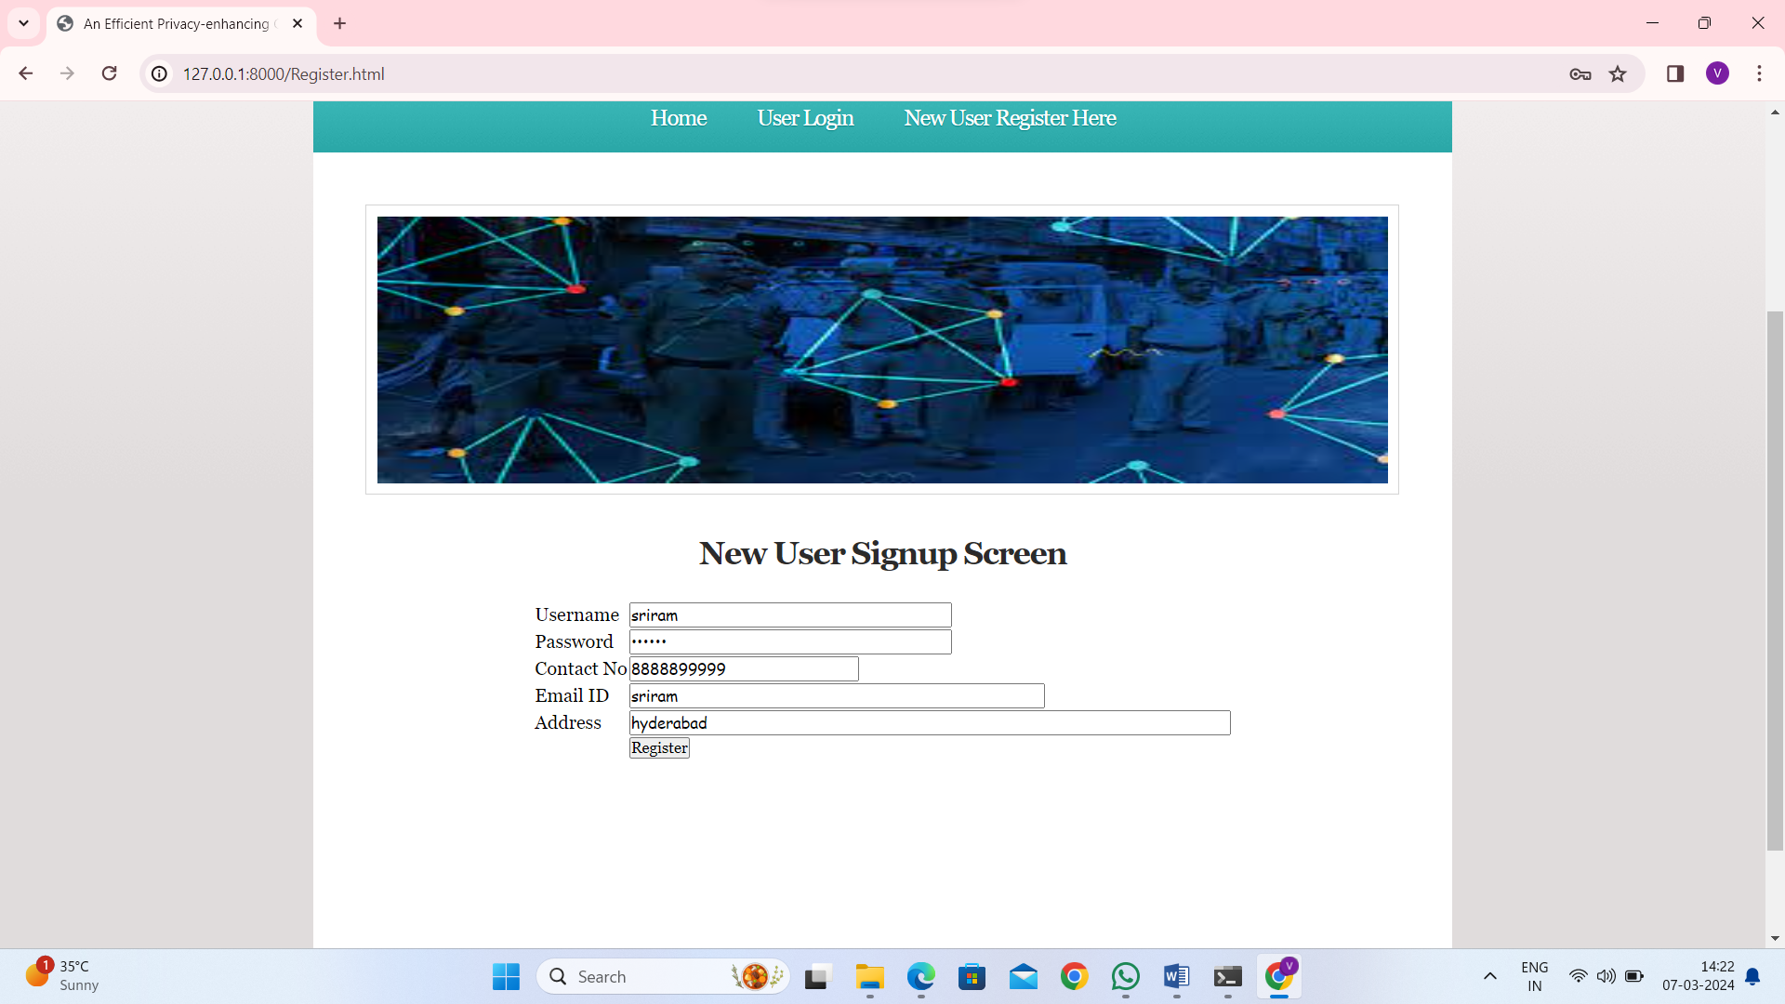
In above screen user is entering sign up details and then press button to get below page
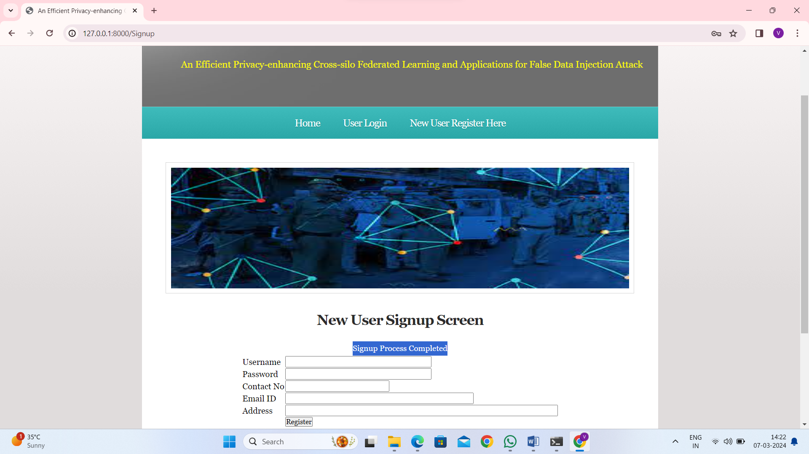
In above screen user sign up completed and now click on ‘User Login’ link to get below page
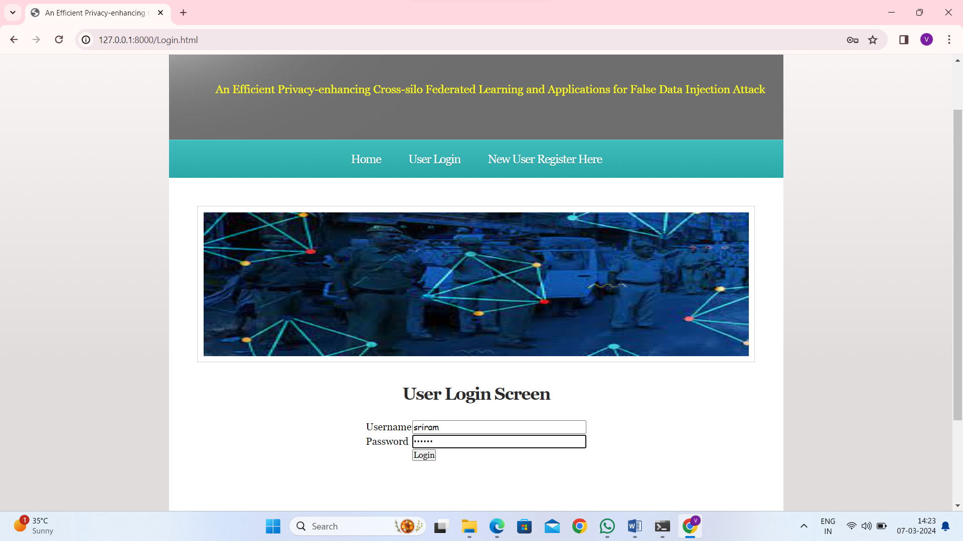
In above screen user is login and after login will get below page
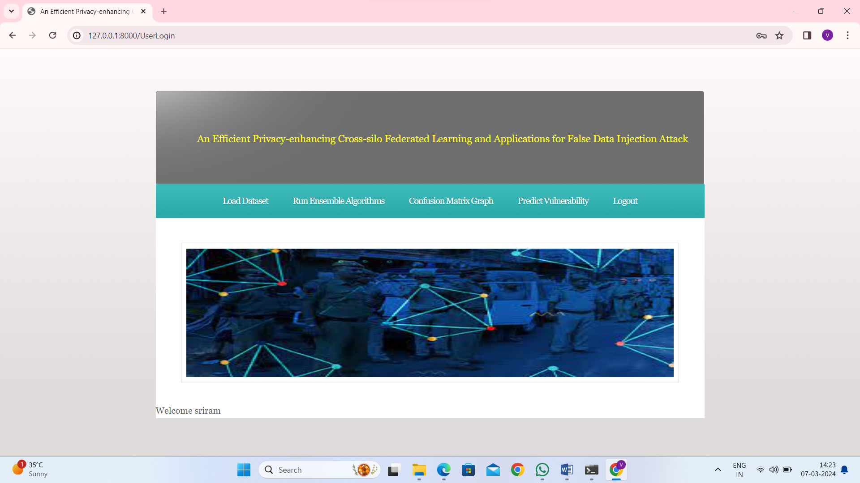
In above screen click on ‘Load Dataset’ link to get below page
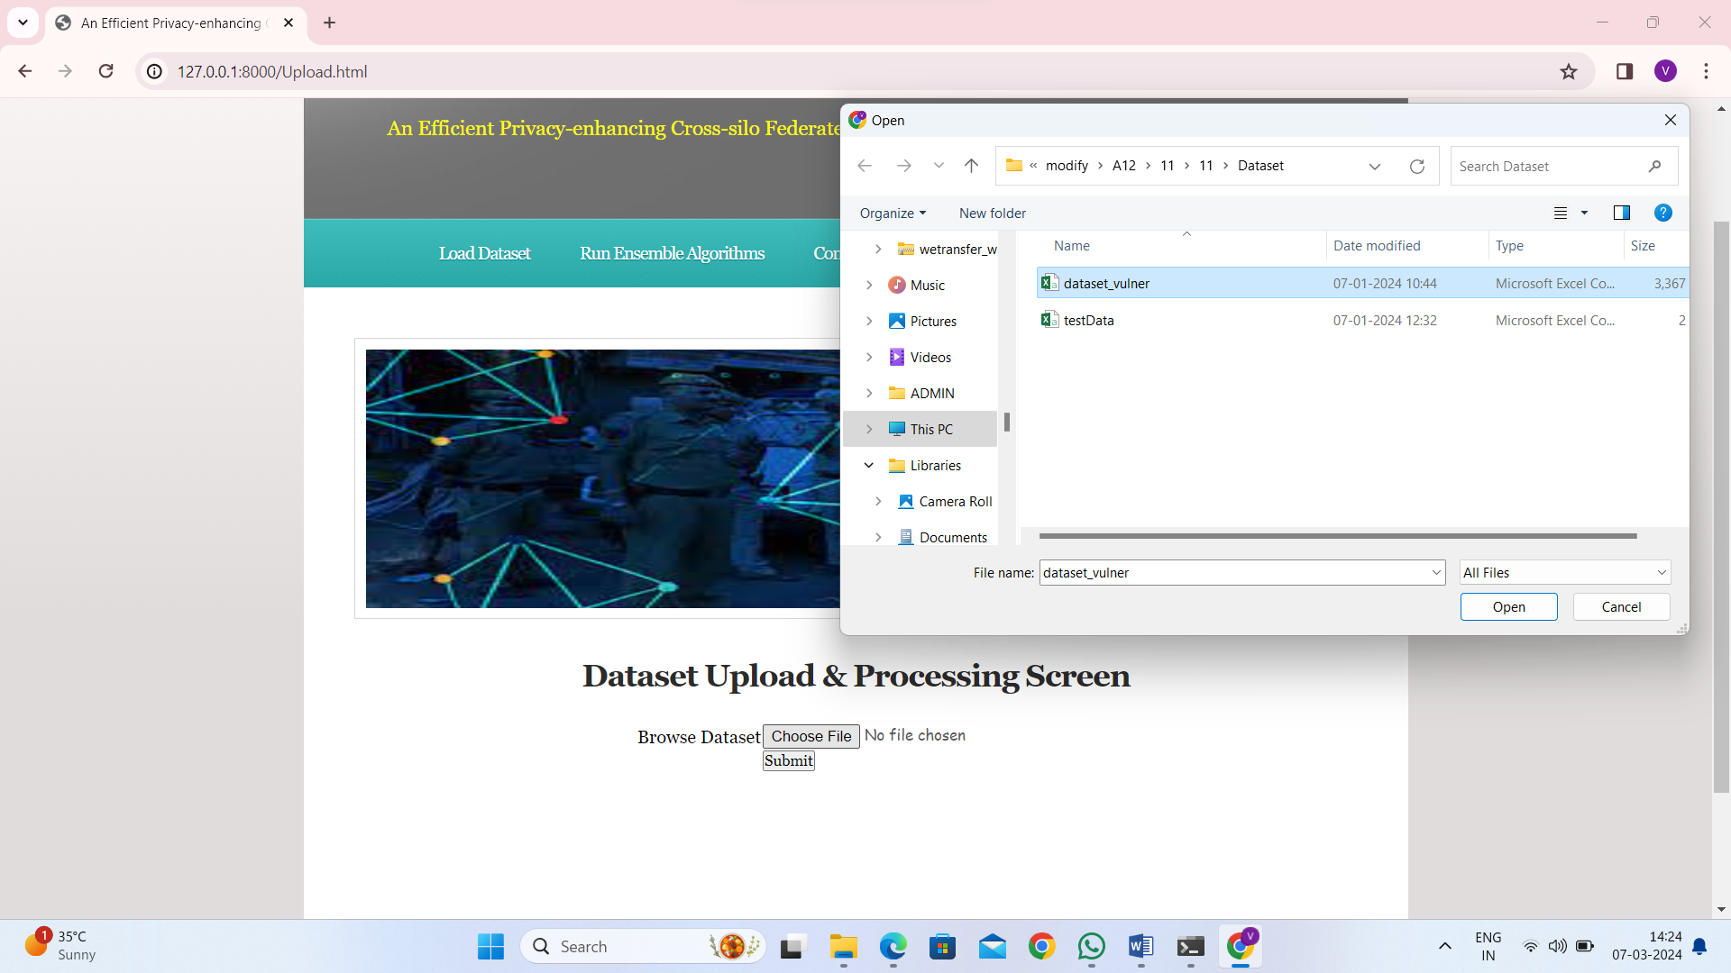
In above screen select and upload ‘dataset_vulner.csv’ file and then click on ‘Open’ and ‘Submit’ button to load dataset and then will get below output
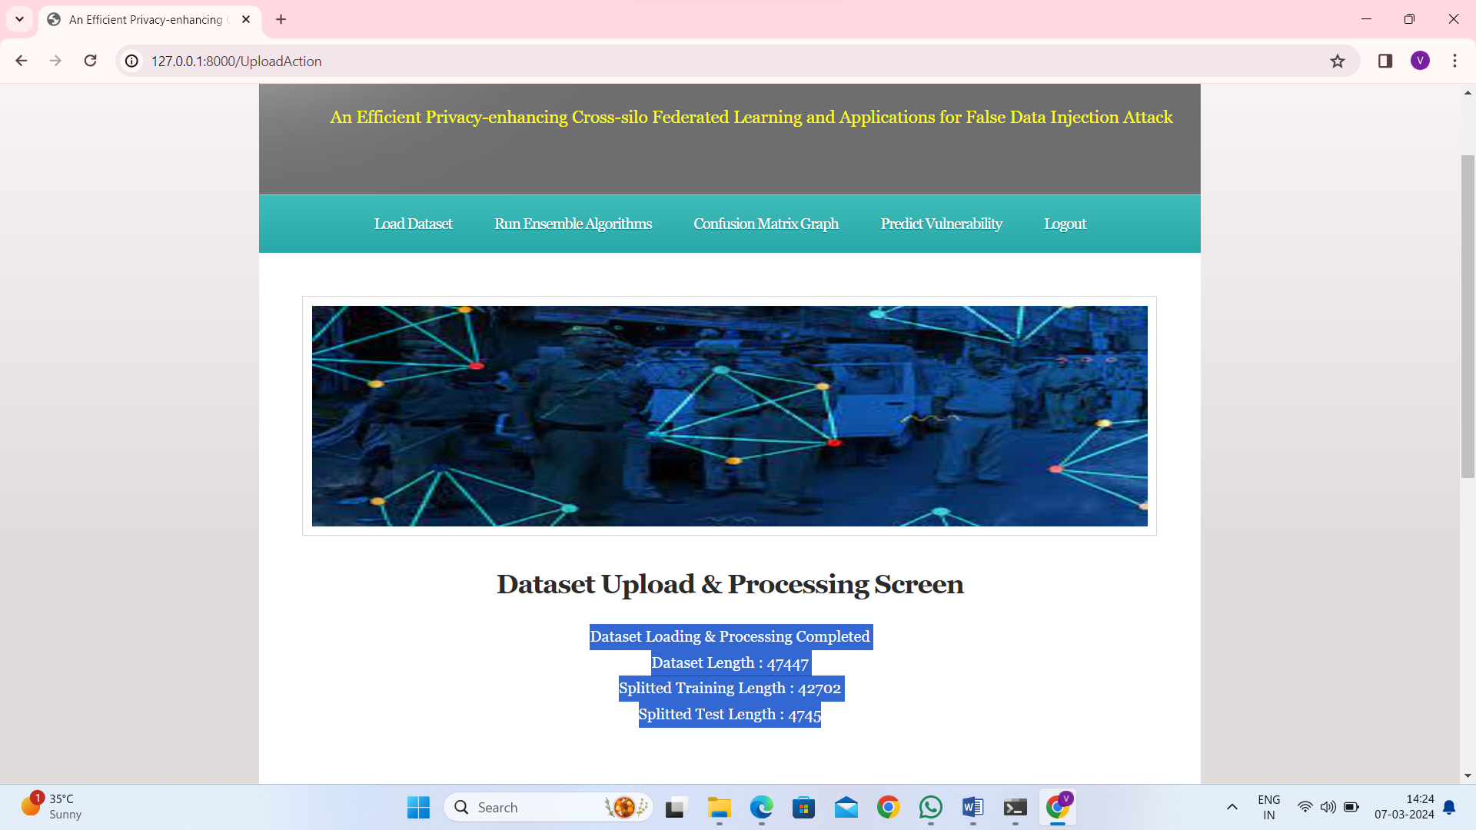
In above screen can see dataset loaded and can see total number of records available in dataset and then can see training number of records on which Machine Learning algorithm get trained and then can see number of test records on which ML will perform prediction to calculate its prediction accuracy %. Now click on ‘Run Ensemble Algorithms’ link to train ensemble algorithm and then will get below output
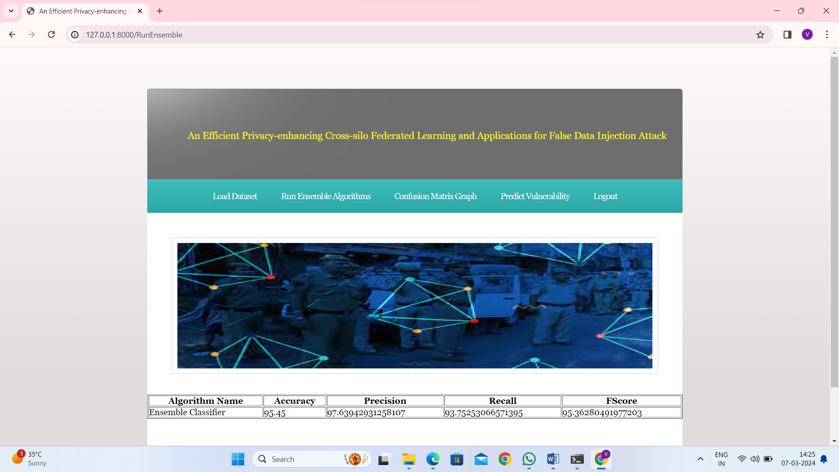
In above screen Ensemble Machine Learning algorithm training completed and can see its prediction accuracy as 95% and can see other metrics like precision, recall and FCSORE. Now click on ‘Confusion Matrix Graph’ link to view visually how many records ensemble predicted correctly and incorrectly
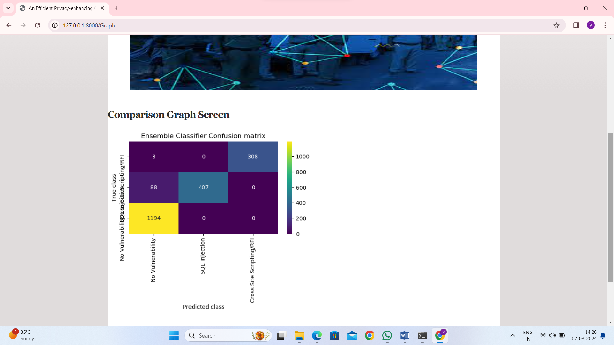
In above graph x-axis represents Predicted Labels and y-axis represents True Labels and then all different colour boxes in diagnol represents correct prediction count and remaining all blue boxes represents incorrect prediction count which are very few. Now click on ‘Predict Vulnerability’ link to upload test data and predict Vulnerability
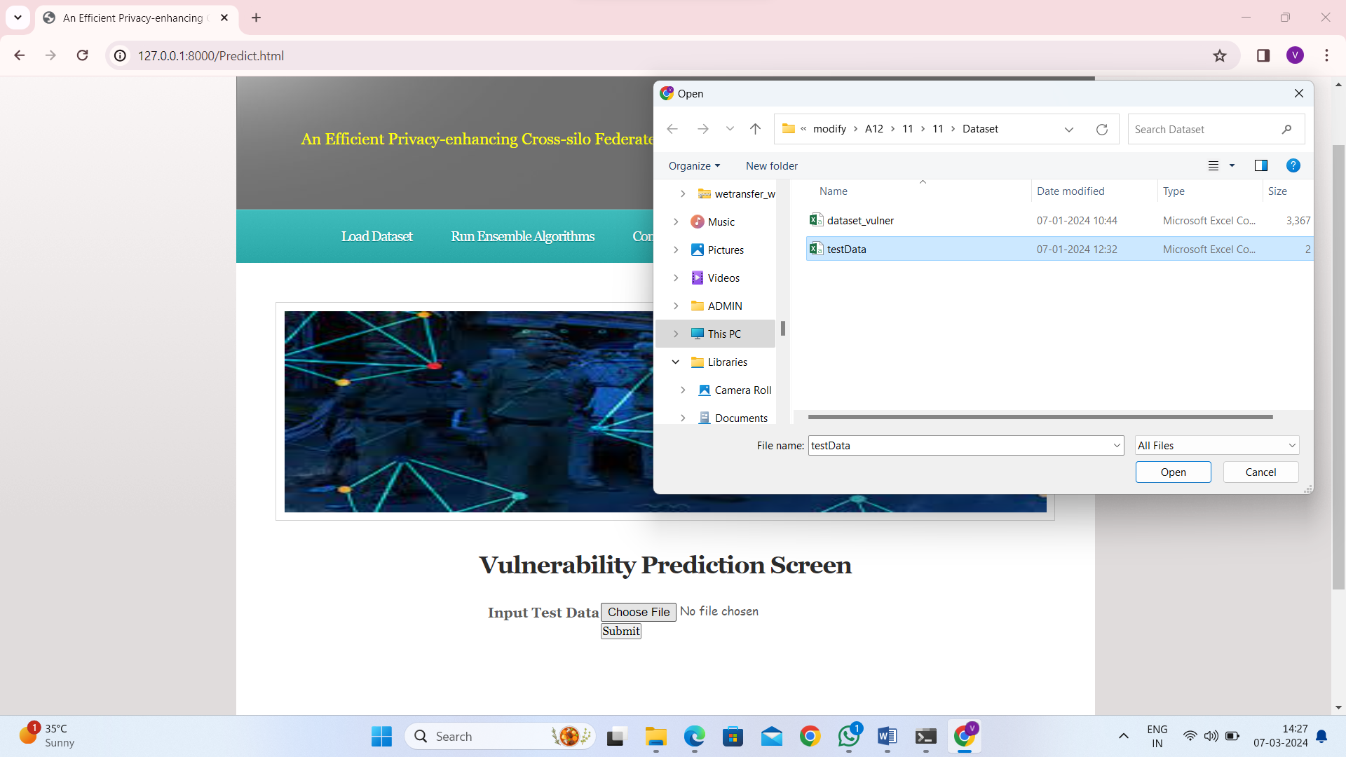
In above screen selecting and uploading ‘testData.csv’ file which contains SQL, XSS and RFI coding commands and then click on ‘Submit’ button to get below output
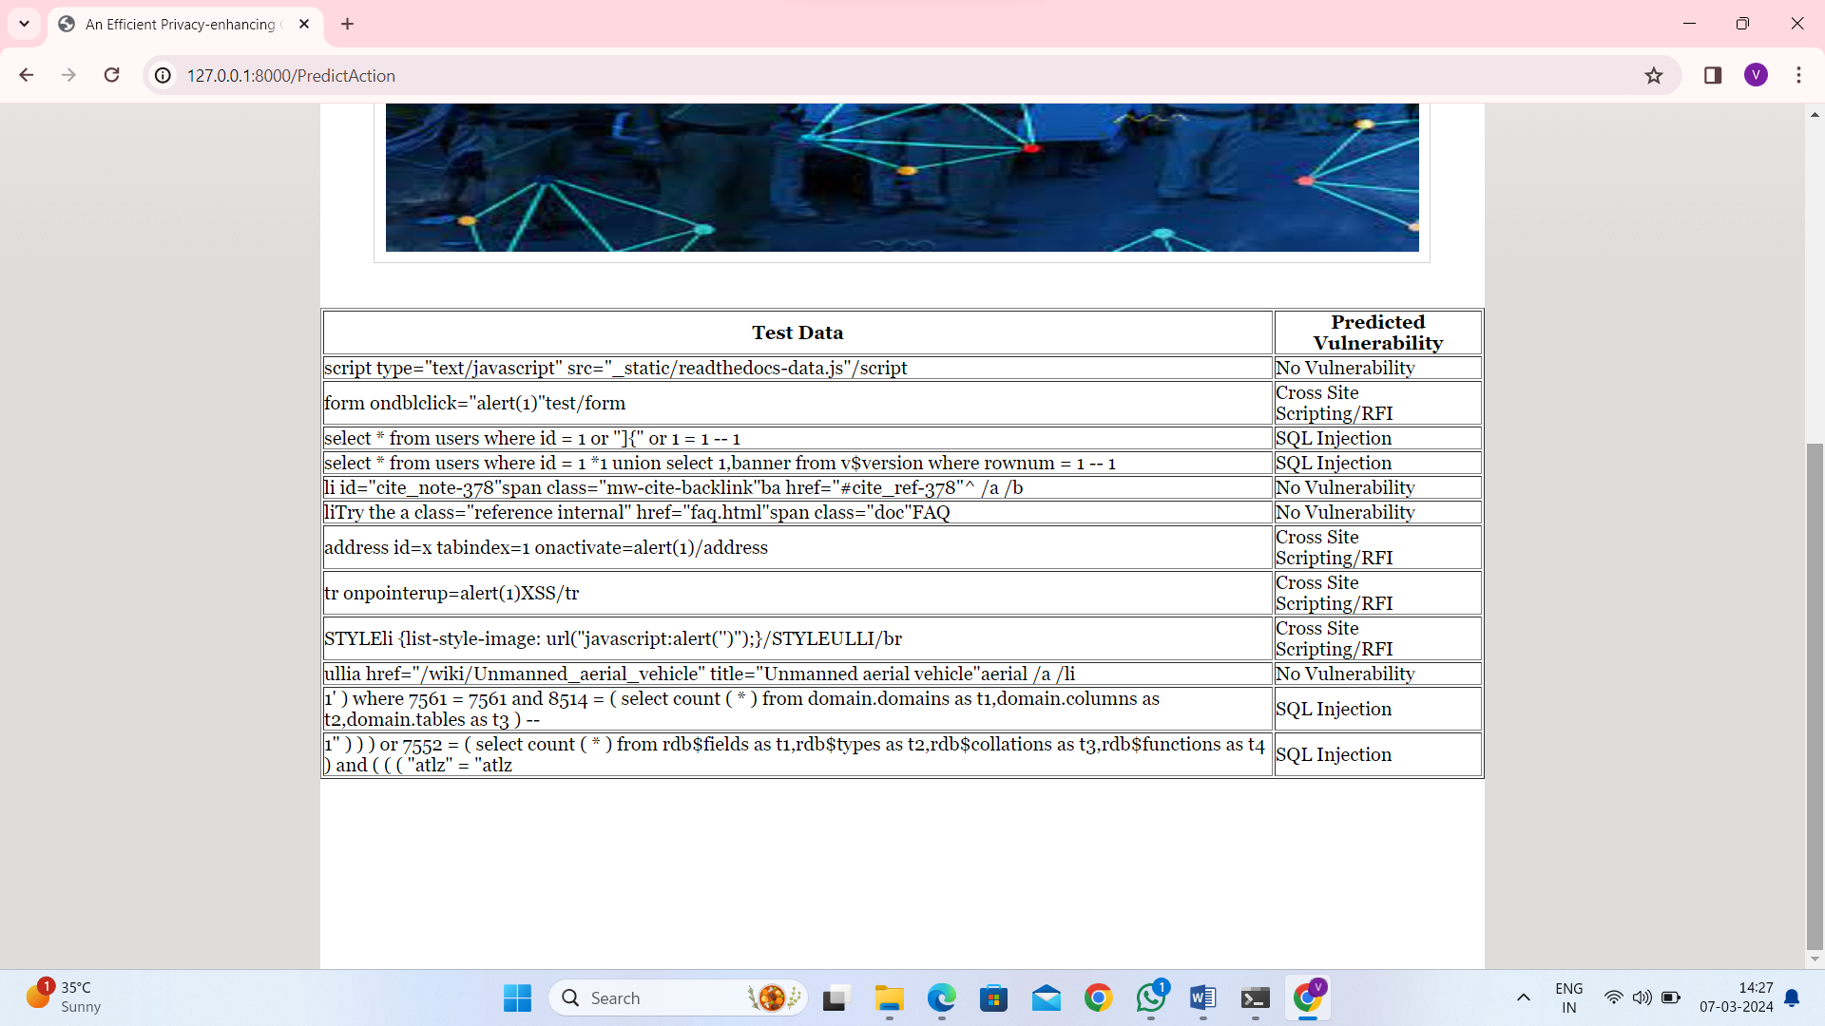
In above table in first column can see SQL queries, XSS and RFI coding commands and in second column can see predicted vulnerability.
So by using above tool you can easily detect all vulnerability and you can add NEW test command in ‘testData.csv’ file which is available inside ‘Dataset’ folder

8. CONCLUSION:
After extensively testing function vulnerability classification using trivial features, n-grams, and suffix trees, we can draw several conclusions. First of all, we see that extracting numerous n-grams does not, thus far, seem to give good classification results, especially if we consider the 74% accuracy that we got from “character diversity “to be a baseline requirement. We also noticed that even when combinations of n-grams were manually selected (in a manner that would normally be illegal and lead to overfitting), the overall result did not improve. However, this study is a good proof-of-concept of a very important point: trivial features can tell us a lot about whether a function is vulnerable or not. There are a few directions in which this research can be taken to improve the results further. First of all, it might be possible to think of additional trivial features to investigate. Secondly, it might also make sense to test some other n-gram selection techniques, as well as some of the SciKit library’s other classification parameters (other than default settings). Third, it would be interesting to look more closely at which characters (or strings) are most important, since this would give us better insight than just “character diversity”. One way to do this would be to run the same character diversity tests after eliminating different strings (square brackets, curly brackets, ++, etc) in pre-processing. Finally, it is possible to test whether the techniques presented in this paper can be used to efficiently detect vulnerabilities in other programming languages (in addition to C).
9. REFERENCES:
[1] Enron email dataset. https://www.cs.cmu.edu/~enron/. Accessed: 2017-07-01.
[2] National vulnerability database. https://nvd.nist.gov. Accessed: 2017-07-01.
[3] V. R. Basili, L. C. Briand, and W. L. Melo. A validation of object-oriented design metrics as quality indicators. IEEE Transactions on software engineering, 22(10):751–761, 1996.
[4] D. Brumley, T.-c. Chiueh, R. Johnson, H. Lin, and D. Song. Rich: Automatically protecting against integer-based vulnerabilities. Department of Electrical and Computing Engineering, page 28, 2007.
[5] N. Dor, M. Rodeh, and M. Sagiv. Cssv: Towards a realistic tool for statically detecting all buffer overflows in c. In ACM Sigplan Notices, volume 38, pages 155–167. ACM, 2003.
[6] D. Evans and D. Larochelle. Improving security using extensible lightweight static analysis. IEEE software, 19(1):42–51, 2002.
[7] P. Godefroid, M. Y. Levin, and D. Molnar. Sage: whitebox fuzzing for security testing. Queue, 10(1):20, 2012.
[8] I. Haller, A. Slowinska, M. Neugschwandtner, and H. Bos. Dowsing for overflows: A guided fuzzer to find buffer boundary violations. In USENIX Security Symposium, pages 49–64, 2013.
[9] A. E. Hassan. Predicting faults using the complexity of code changes. In Proceedings of the 31st International Conference on Software Engineering, pages 78–88. IEEE Computer Society, 2009.
[10] S. Kim, T. Zimmermann, E. J. Whitehead Jr, and A. Zeller. Predicting faults from cached history. In Proceedings of the 29th international conference on Software Engineering, pages 489–498. IEEE Computer Society, 2007.
[11] D. Larochelle, D. Evans, et al. Statically detecting likely buffer overflow vulnerabilities. In USENIX Security Symposium, volume 32. Washington DC, 2001.
[12] P. Lathar, R. Shah, and K. Srinivasa. Stacy-static code analysis for enhanced vulnerability detection. Cogent Engineering, 4(1):1335470, 2017.
[13] R. Ma, Y. Yan, L. Wang, C. Hu, and J. Xue. Static buffer overflow detection for c/c++ source code based on abstract syntax tree. Journal of Residuals Science & Technology, 13(6), 2016.
[14] R. Moser, W. Pedrycz, and G. Succi. A comparative analysis of the efficiency of change metrics and static code attributes for defect prediction. In Proceedings of the 30th international conference on Software engineering, pages 181–190. ACM, 2008.
[15] R. M. Pampapathi, B. G. Mirkin, and M. Levene. A suffix tree approach to antispam email filtering. Machine Learning, 65(1):309–338, 2006.
[16] E. Penttilä et al. Improving c++ software quality with static code analysis. N/A, 2014.
[17] H. Shacham. The geometry of innocent flesh on the bone: Return-into-libc without function calls (on the x86). In Proceedings of the 14th ACM Conference on Computer and Communications Security, CCS ’07, pages 552–561, New York, NY, USA, 2007. ACM.
[18] Y. Shin and L. Williams. An empirical model to predict security vulnerabilities using code complexity metrics. In Proceedings of the Second ACM-IEEE international symposium on Empirical software engineering and measurement, pages 315–317. ACM, 2008.
[19] J. Viega, J.-T. Bloch, Y. Kohno, and G. McGraw. Its4: A static vulnerability scanner for c and c++ code. In Computer Security Applications, 2000. ACSAC’00. 16th Annual Conference, pages 257–267. IEEE, 2000.
[20] D. Wagner, J. S. Foster, E. A. Brewer, and A. Aiken. A first step towards automated detection of buffer overrun vulnerabilities. In NDSS, pages 2000–02, 2000.

